National College of Ireland

BSc in Computing

2019/2020

***2020 Olympic Prediction & Analysis on Athlete Performance***

Technical Report

Rehan Naeem

X16333223

BSc (Hons) in Computing

Specialisation: Data Analytics



Contents

Executive Summary 4

1 Introduction 5

1.1 Background 5

1.2 Project Scope 6

1.3 Aims 6

1.4 Methodology 7

1.5 Project Plan 9

1.6 Resources Required 11

1.7 Technical Approach 11

1.8 Technical Details 12

1.9 Technical Hardware 12

2 System Requirements 13

2.1 Functional requirements 13

Use Case 13

2.1.1 Requirement 1 Database creation 13

2.1.2 Requirement 2 Data Visualization 15

2.1.3 Requirement 3 User Interface 16

2.1.4 Data Requirements 18

2.1.5 Performance/Response time requirement 18

2.1.6 Availability Requirement 19

2.1.7 Recover requirement 19

2.1.8 Security requirement 19

2.1.9 Reliability requirement 19

2.1.10 Maintainability requirement 19

2.1.11 Extendibility requirement 20

2.1.12 Reusability requirement 20

2.2 Testing 20

2.2.1 Statistical Tests 20

2.2.2 Most improved Devloping country 20

2.2.3 Time series/ Forecasting Winners 21

2.2.4 Can an athlete’s attributes predict the outcome for certain sports? 21

2.3 GUI 22

3 System Architecture 23

3.1 Implementation 23

3.1.1 Data Selection 23

3.1.2 Data Cleansing / Pre-Processing 23

3.1.3 Data Transformation 29

3.1.4 Statistical Tests 31

3.1.5 Which Developing Country has improved the most? 34

3.1.6 Data Mining 35

3.1.7 Can an athlete’s attributes predict the outcome for certain sports? 43

3.1.8 Time Series Forecasting 49

4 Results & Conclusions 52

4.1 Mann-Whitney U Tests 52

4.2 Most Improved Developing Country 53

4.3 Can an athlete’s attributes predict the outcome for certain sports? 55

4.4 Time Series 59

5 Further Development or Research 62

6 References 63

7 Appendix 65

7.1 Appendix A: Definitions, Acronyms, and Abbreviations 65

7.2 Appendix B: Literature Review 66

7.3 Appendix C: Code and results 69

7.4 Appendix D: Monthly Journals 77

# Executive Summary

The Olympic Games is a major global athletic event that takes place every 4 years since 1896 when the first Olympic games were held in Athens, Greece. In the Olympics Athletes from across the globe participate in various sporting events and represent their country to prove that they are the best of the best on a global scale.

People from all over the world tune in to watch these athletes take part in the various sports and to see who will win and possibly break or make a new world record. In the last Olympic Games 206 countries participated with approximately 10,500 athletes taking part. It is a key strategy for the participating countries training camps to take make sure they improve their performance for the next Olympic Games so they can ‘Bring home the Glory’.

My project will help the Olympic training coaches for sports such as athletics or swimming and show them the predictions for the upcoming Tokyo Olympic Games allowing them to see the visual trends in the performance of their athletes and potentially create strategies using the analysis found on other teams and be more prepared to come out on top and to minimise losses. My project will also allow the user to view various statistics throughout the history of the Olympics so they can see which countries are predicted to score high in the Olympics and it may help those who would be willing to place bets on certain events, it may increase the individuals confidence on placing a bet.

In this technical report, I will set out the aims, ambitions, and requirements to analyse the upcoming 2020 Tokyo Olympic Games and to show the improvement in athlete performance. I intend to meet these ambitions by using the programming language R to retrieve data from relevant sources, clean, transform and evaluate the data to gain knowledge on the data to predict outcomes.

# Introduction

The purpose of this document is to set out the requirements for the development of my data analysis project with the intent to study various strategies I can use for the 2020 Olympic Predictions & Analysing the Improvement in Athlete Performance. I will attempt to predict the outcome of the upcoming Olympic Games based on a study of records from previous Olympic Games.

The intended customers are all participating Olympic Teams, the players taking part in the Games & fans of the Olympic Games.

## Background

As mentioned before the Olympic Games is a very large globally known athletic event where athletes from across the world compete against one another to show who is the best. Each Olympic Games the crowds get bigger and the views get higher, in 2016 approximately 7.5 million tickets were sold throughout the course of the event and over 3.6 Billion live viewers internationally. The revenue generated by the Games is immense and the fact new hosting countries show off the new stadiums with the latest architectural engineering and design which cost over billions of dollars themselves is very appealing to members of the public. Furthermore, the amount of advertising done is on a very large scale. In an article written by Megan Graham for CNBC she states that *“NBCUniversal has received more than $1 billion in national advertising commitments for the 2020 Summer Olympics in Tokyo” (Graham, 2019). In comparison to the 2016 Summer Olympic Games in Rio Tokyo was set to receive “*double-digit growth” in advertisement revenue.

In more recent articles it is suggested that this figure which was reported in 2019 is set to decrease due to the Covid-19 pandemic as advertisers and sponsors pull out. As stated by Christina Gough *“With the future of the event still up in the air, the organizers stand to lose over 900 million U.S. dollars committed by over 70 local sponsorship partners in Japan.” (Gough, 2020)*

I have always been interested in the Olympics from a young age, watching as much as I possibly could during my Summer holidays as a child. I remember when watching the 100m Sprint live and watching Usain Bolt breaking the world record and it absolutely mind breaking. Therefore, I saw it very fit that my project would be about the 2020 Olympic Games. By the time, this project has been submitted the 2020 games would have initially begun. However due to the Covid-19 pandemic the 2020 Tokyo Olympic games have been cancelled for this year and will hopefully occur in 2021 depending on the situation with the pandemic.

For many countries this would have been a chance for them to show the world that they can produce some of the best athletes in the world. Some countries will bring home Gold, Silver or Bronze and others won’t, so it is in the interest of all teams to make sure that they improve on their performance for the next Olympic Games in order to showcase their talent and skill as best as they possibly can as they will be representing their home country.

## Project Scope

The scope of the project is to conduct a data analysis on data gathered from Kaggle which has previous Olympic Games data and use it to predict the future outcomes for the upcoming Olympic Games & to ask the improvement of athletes throughout the course of the Olympic games.

I have used R for my programming language to develop a solution for this project. I will also be using data sets collected from Kaggle to show the comparisons and any statistical information that needs to be viewed.

## Aims

The Aim for this project is to get the Olympic Data and visualize it and be able to show the advancements that have been made by countries by showing the difference in the performance of athletes over the course of the history of the Olympics. I had also intended to predict the outcome for the 2020 Tokyo Olympic Games which was to be done by analyzing the data and searching for trends on previous winners. I originally attempted to predict which country will win what medal in which event and which country will not win any medals. However, initial exploratory analysis indicated that the attributes of individual athletes such as height, weight, age etc. are not good indicators for success across all Olympic events. Thus, the aims of this project are:

* To see if an athlete’s attributes (Height, Weight. Age. Country of Origin & the sport they participate in) can be used to see if it is possible to predict the outcome of certain sports
* Predict which Country will come 1st, 2nd & 3rd

I also have sub aims which are:

* To see which developing country has improved the most in terms of winning medals
* Do GDP statistics influence athletic performance?

## Methodology

This section will detail the methodology used throughout the project. The chosen methodology for this project is KDD (Knowledge Discovery in Databases). This method is for analyzing data and consist of a few steps which will help in performing data mining for my project.

KDD is used within the following areas:

* Database
* Data Visualization
* Getting statistics
* Artificial Intelligence
* Machine Learning

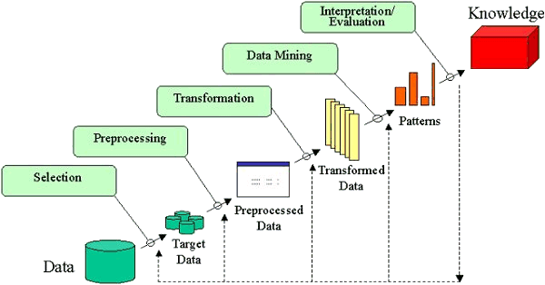

Figure: kdd methodology

Here are the steps involved with implementing the KDD methodology and how it was applied to this project:

1. **Identifying the goal**

To identify my goal for my project I needed to find the right dataset that would suit my needs for my project, and what I intend to do with the data and how interested I am with the chosen dataset.

1. **Finding the best dataset**

Here I went through many websites where I searched for datasets that had data from preferably all the Olympic games. In the end I found a dataset on Kaggle which consisted of Olympic data from the first games in 1896 till the most recent in 2016 which was in a csv format. I was also looking for a dataset on the socio-economic data of all countries as it was part of one of my aims for my project, I found a dataset of my interest on Kaggle.

1. **Brainstorming**

Once I had found my dataset, I started brainstorming ideas on what I can do with the gathered datasets. The main idea I came up with was predicting who will in the 2020 Olympic Games so I needed to find out and do research on what algorithms will be required to complete this aspect of this project.

1. **Pre-processing (Data Cleansing)**

Here, the job is to remove any inaccuracies and corrupt data within the dataset. In my case the dataset only consisted of NA (Not Available) values. To correct this, I had the choice of either using Excel or using the R programming language. I also had the opportunity to get rid of columns and rows of data that was not relevant to me or for the analysis I wanted to conduct.

1. **Transforming the dataset**

The transformation of the dataset would be done using the R programming language on R studio. I would load the dataset onto R Studio and begin to conduct analysis.

1. **Data Mining**

Data mining is a process of discovering patterns in large data sets, such as the one I will be using for my project and involving methods of machine learning, statistical analysis, and database systems. For data mining I will be using the following:

* **Machine Learning:** this is a type of artificial intelligence; it is an algorithm that can learn through experience
* **Random Forest:** a method of machine learning algorithm used to work on classification & problems
* **Multi-nominal Logistic Regression:** another machine learning algorithm used to work on classification & problems derived from logistic regression
* **Ordinal Regression:** machine learning algorithm used to work on classification

1. **Evaluation of the results**

In this final stage using R, statistical analysis would have been conducted and machine learning algorithms would have been implemented in order to get results for the data within the dataset. Once the results are gathered such as a visual representation of a trend in the data, I would determine the meaning of the output on a dashboard.

## Project Plan

Below is a Gantt chart which sets out a guideline for the project to ensure that milestones and deliverables of the projects are met.

For the first semester of college, I plan on laying the foundation work for my project. My goal is to have completed the required research on datasets, techniques and methods and merge this with the training and skills I gain from the college modules of my first semester and focus on the application and technical part of my project in my second semester.

Figure 1: Gantt Chart Semester 1

After having my deferral for my project approved, I had more time to work on the completion of my project for which I created a new Gantt chart beginning in June 2020 which is below.

Figure 2: Gantt Chart for August Submission

I made these Gantt Charts using Microsoft Excel.

## Resources Required

For the research section on my project, I looked at past projects that have been made in relation to this topic.

I plan on using the KDD methodology as a base for my project.

I have done research on similar studies in this area of data analysis. I have researched a study that focuses on the selection of players between different rounds of the draft and their outcome.

Throughout my final year I have learned to develop skills in

* R Programming for Data Science
* Statistics for Data Science
* Microsoft Excel

In semester 2 I will be learning the below topics:

* Machine Learning for Data Science
* Scrapy: Web Scraping/Crawling with Python
* Advanced Business Data Analysis

I have also taken multiple courses on the resource DataCamp, which is an interactive learning site for data science.

## Technical Approach

When making the decision to pick Data Analytics as my specialization for fourth year, I immediately started to research project ideas. I looked at websites such as Reddit, Kaggle and Data.World to give me an idea on how to research for my project.

I looked at ways to get data through the technique of Web Scraping, APIs during my lectures and by researching online.

After researching the methods on how to get the data I needed to make my project viable I then considered the topic I wanted to focus my project on. As mentioned above I have a passion and interest in the Olympic Games, and I believe that by working on something that I am interested in it will benefit me and my project.

Approach Taken:

* Research ideas for final year project
* Find an appropriately sized dataset for the project
* Conduct data cleansing on dataset so it can be fit for use
* Conduct analysis on data to discover trends
* Create visualizations on data to allow for better understanding of the dataset
* Make video presentation to show and discuss my findings.

## Technical Details

* Using R studio to analyse data from my dataset, create charts and plots
* Use R to clean dataset and to create subsets for data to experiment with the data
* Use R studio to perform Machine Learning Techniques
* Use Microsoft Excel to view data and create subsets
* Use Microsoft Word to report my findings every step of the way until I complete my technical report
* Use Tableau to visualize data in an interactive an intuitive manner

## Technical Hardware

The computer specifications I am on performing my project on are:

* Intel Core i7-6600U Dual Core Processor
* 8GB DDR4-2400MHz
* 250GB Solid State Drive

# System Requirements

## Functional requirements

For the functional requirements of my project I will preview use cases that are needed to make my project functional. In my case I am the main user and I will show how I am accessing the data.

The below use cases are the most important functional requirements for accessing the data that is needed to make my project viable. I will provide the techniques and methods used to achieve these use cases in detail below.

### Use Case

### Requirement 1 Database creation

**Description & Priority**

This requirement will be utilized at the start of the project. Whether the data is being stored on a harddrive or a datbase such as MySQL this requirement is of high importance.

**Use Case**

**Scope**

The scope of this use case is to create a safe and secure storage system that will be maintained during the project.

**Use Case Diagram**

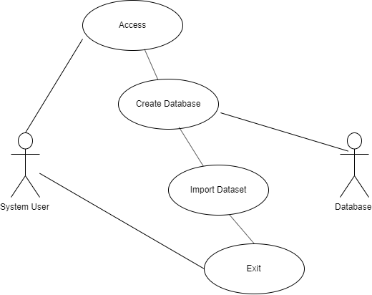

**Figure 3: Database Creation Use Case**

**Flow Description**

**Pre-condition**

Database is accessible through GUI or SQL commands.

**Activation**

This use case starts when the storage is accessed.

**Main flow**

1. The user starts the database application
2. The user creates some form of storage for the data
3. The user imports the dataset
4. The application is exited

**Exceptional flow**

E1: Failed to start application

1. The system fails to start
2. The system is restarted
3. The use case starts from the beginning of the main flow

**Termination**

The database application is closed.

**Postcondition**

The data is stored secure and safely.

### Requirement 2 Data Visualization

**Description & Priority**

This requirement will be at the end of the project when I am visualing the data on a dashboard software such as Tableau.

**Use Case**

**Scope**

The scope of this use case is for the system user to create and visualise the data.

**Use Case Diagram**

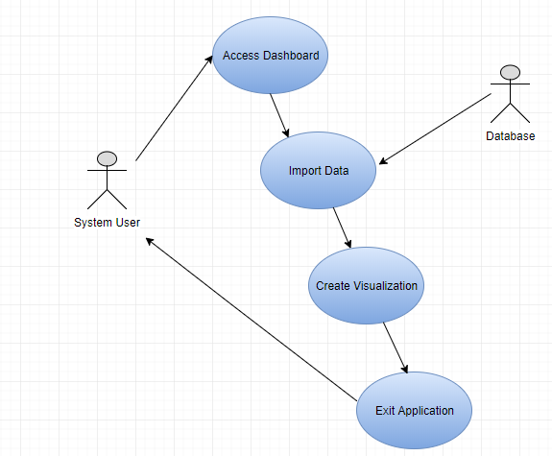

**Figure 4: Dashboard Creation Use Case**

**Flow Description**

**Pre-condition**

Dashboard software is accessible.

**Activation**

This use case starts when the dashboard software is accessed.

**Main flow**

1. The user starts dashboard software
2. The user imports the data from the database
3. The user creates the visualizations from the data
4. The application is exited

**Exceptional flow**

E1: Failed to start application

1. The system fails to start
2. The system is restarted
3. The use case starts from the beginning of the main flow

**Termination**

The dashboard application is closed.

**Postcondition**

The data visualization is stored safely.

### Requirement 3 User Interface

**Description & Priority**

This use case for my project will be used to show how the ser will interact with the GUI and the back end process that wil take place in order to display the selected information

.

**Use Case**

**Scope**

The scope of this use case is to make a easy to use, intuitive web page where the user can look at the statistics selected by choosing the desired information they wish to see displayed.

**Use Case Diagram**

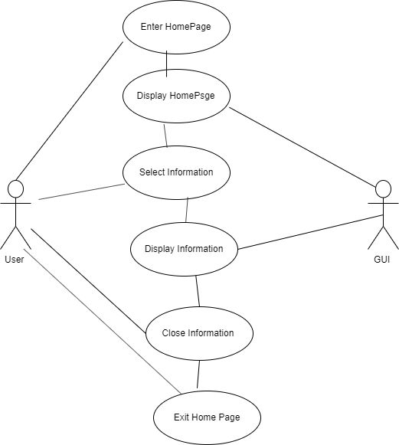

**Figure 5: User Interface**

**Flow Description**

**Pre-condition**

The GUI will be accessed by browser and developed using HTML and CSS

**Activation**

This use case starts when the web page is loaded.

**Main flow**

1. The user starts at the home page
2. The user selects desired information
3. The information is then displayed to the ser
4. The application will exit once the user press exit.

**Exceptional flow**

E1: Failed to start application

1. The system fails to start
2. The system is restarted
3. The use case starts from the beginning of the main flow

**Termination**

The webpage is closed.

**Postcondition**

The webpage will be hosted local and the data to display will be stored securely.

### Data Requirements

As my project is a data analytics study the data requirement for my project is of high importance. The data requirements for my project will be that the datasets I acquire are of exceptional quality and integrity.

### Performance/Response time requirement

The performance and response time requirement for my project will be related to the access to data. R will be used if it is required to scrape or pull data from certain websites or APIs it will be dependent how the website or API responds. Once I have the data, the performance then relies on the machine or database it is stored on and the integrity of the data itself.

### Availability Requirement

The availability requirement of my project will be related to the availability of the datasets (see Testing section below on current datasets). Once the data is taken from sources, it will be available from the database or the hard drive it is stored on.

### Recover requirement

The recover requirement of my project is of great importance. As this is a project focused on data it is important that the data and files are backed up in case of disaster. All files will be backed up on Google Drive & OneDrive, and the scripts and data will be stored on Google Drive. My code is also on my GitHub.

### Security requirement

The project will be done on a password encrypted laptop and the files and scripts as stated in the recover requirement will be on password protected sites such as Google Drive, GitHub & OneDrive.

### Reliability requirement

The web scraping technique is widely used through the data analytics community with packages that are regularly updated. The Olympic dataset which I am using has had good reviews on Kaggle and has been used by many others.

### Maintainability requirement

The project is due for final assessment in August, however, as I have a keen interest in the Olympic Games, I will most likely further develop this and make another application for the 2024 Olympic Games.

### Extendibility requirement

There is good scope for extendibility for this project; please see System Evolution section.

### Reusability requirement

The scripts used to access and manipulate the data will be reusable in other projects as I intend to use good programming practice to make this requirement viable.

## Testing

### Statistical Tests

**Success**: to have a success when performing the required physical test, I must receive a p-value higher or lower than my alpha value.

**Failure**: An error message will appear indicating the user to verify the parameters, the user would try again until there is a success.

**Expected Results**: the expected result is to have a p-value less than the alpha value to deem the null hypothesis false and the alternative hypothesis true.

**Observed Result**: the observed result was the expected result

### Most improved Devloping country

**Success**: for a success R would provide me with a visualisation showing the history of medals earned by each country since their introduction to the Olympic Games.

**Failure**: for a failure to occur there would be an error possibly saying to check the parameters and another attempt would be made until there was success.

**Expected Result**: expected to see a GGPlot that will show me Bronze, Silver and Gold medals earned by a country ever since their first time at the Olympic Games.

**Observed result**: the observed result was the expected result

### Time series/ Forecasting Winners

**Success**: R would need to provide me with a plot that will show the predicted value for the total number of Bronze, Silver & Gold medals expected to win for each of the selected countries.

**Failure**: for a failure to occur there would be an error possibly saying to check the parameters and another attempt would be made until there was success.

**Expected Result**: R to provide me with a plot that will show the predicted value for the total number of Bronze, Silver & Gold medals expected to win for each of the selected countries.

**Observed Result:** the observed result was the expected result

For the time series to be truly successful a comparison against another time series forecast of the same data would be required. For the comparison Tableau was used, alterations were made to the dataset to run the forecasting in Tableau, the figures were the same. Once the results from Tableau were received, there was a better visual understanding of the predictions and allowed the comparison between the Tableau and R generated results to be more efficient. The results of this analysis have been discussed in section 4.3 of the document.

### Can an athlete’s attributes predict the outcome for certain sports?

**Success:** For a success there would need be an output for predicted data using the test data.

**Failure**: for a failure to occur there would be an error possibly saying to check the parameters and another attempt would be made until there was success.

**Expected Results**: the prediction data would need to be similar to the actual test data. While also having high values for Sensitivity after running a confusion matrix.

**Observed Result:** the observed result was the expected result for some countries however there were other countries whose predicted value did not come close to the test data.

This analysis would be feasible if the generated output for the prediction on the test data was accurate. The accuracy was measured using a confusion matrix. Initially, the contents of the entire dataset to try ad predict which country will get what result in the upcoming Olympic Games. After further analysis on the results provided by this approach it was deemed too inaccurate as the confusion matrix had shown me there was a bias for the prediction to favour the imbalanced data which was ‘0’ for no medal. Due to this result a new approach was required. I decided to analyse which sport would be best for predicting medals. The reason being as by selecting specific sports there will be less data imbalance as the dataset would be small and the predictions would be more accurate in the confusion matrix. The preparation for this approach has been discussed in section 3.1.5 and the discussion on results in section 4.2.

## GUI

For my GUI I will be using a tool called Tableau which is used by businesses to show visualizations of their data for a deeper understanding. I will be presenting my visualizations on tableau as they allow the use of an interactive dashboard which allows the user to interact with the data visualization, it’s also very functional as it offers features such as forecasting.

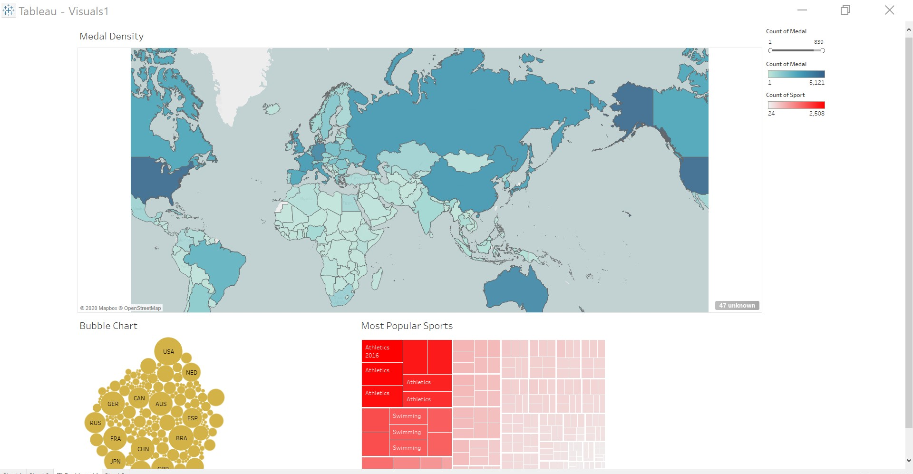

Figure 6: Tableau Dashboard for data visualization

# System Architecture

## Implementation

### Data Selection

The first stage of my project involved in gathering the most suitable dataset to which I would conduct my data analysis on and make the machine learning models for my predictions. I got my dataset for the Olympics on Kaggle and I downloaded the dataset to my PC. The dataset is publicly available and can be accessed using this link, <https://www.kaggle.com/heesoo37/120-years-of-olympic-history-athletes-and-results>.

Later I found a dataset with the socioeconomic figures for countries which I found on Kaggle in the link provided below. The data is collected from the United Nations and the World Bank, I used the data to search for the GDP per capita figures for countries to determine if they were a developing or developed country.

<https://www.kaggle.com/krukmat/demographic-and-socioeconomic-unesco>.

### Data Cleansing / Pre-Processing

In this stage, the goal is to clean the dataset. When cleaning the dataset, you must be careful that you do not manipulate the dataset which could have an impact on the results. When looking at the original Olympics dataset. Below you can see what the original dataset looked like.

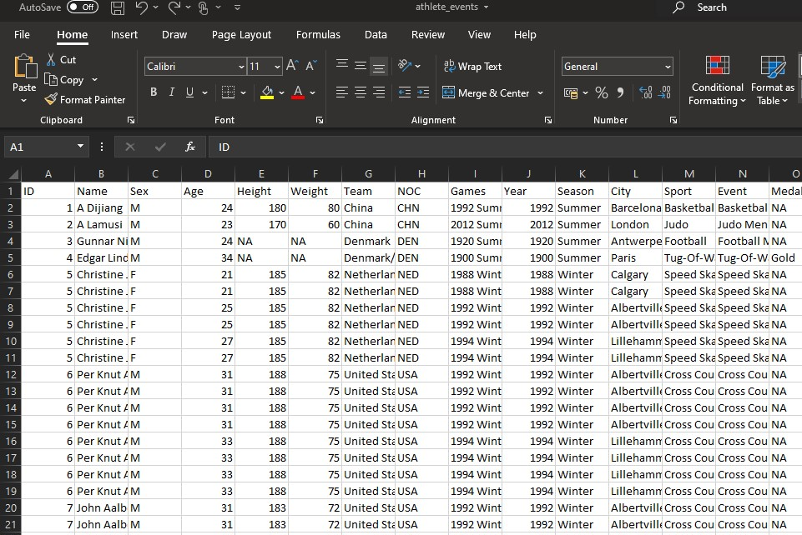

Figure 7: the original dataset downloaded from Kaggle

As you can see in figure 7, the original dataset consisted of a lot of NA (Not available) values which are also known as missing values. Using a few lines of code in R I can see exactly how many NA values there are throughout the entire dataset and then I will take you through the process of how I dealt with these missing values. Below is a snippet of the summary() function I used in R to see how many total missing values there are in each column within the original dataset.

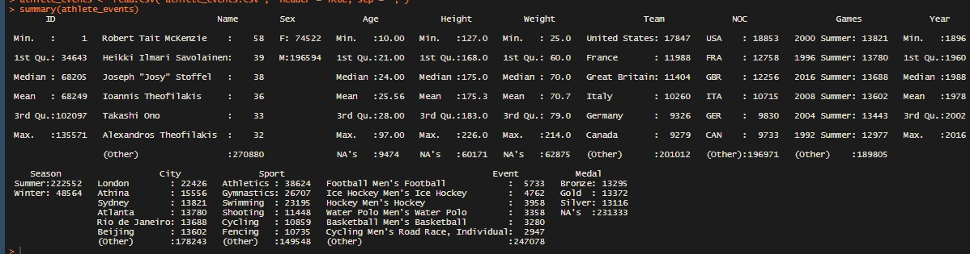

Figure 8: total missing values shown in R for each variable

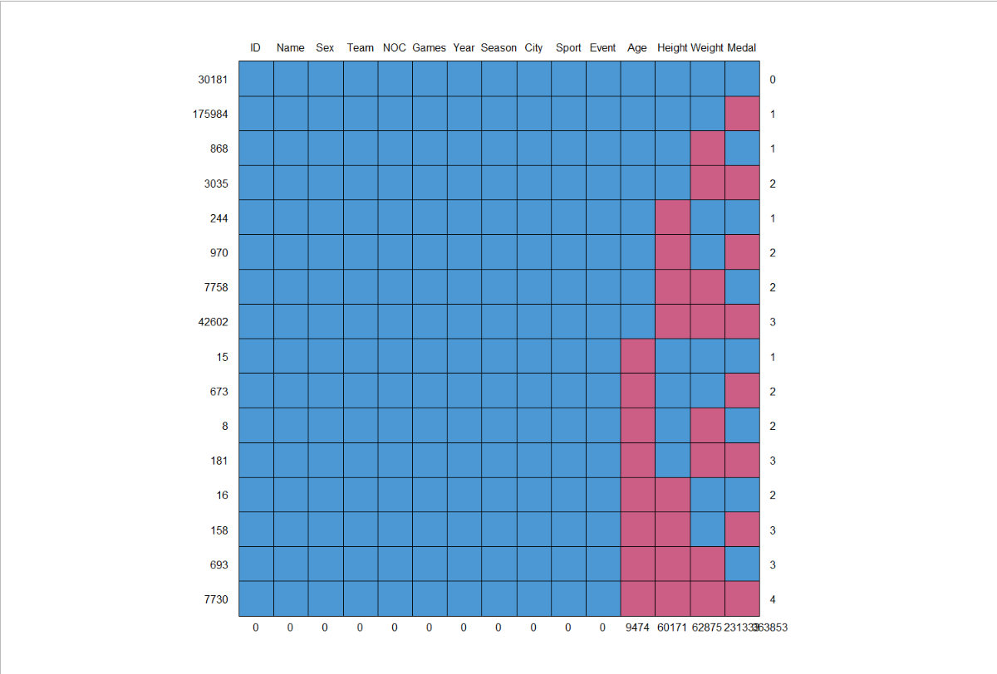As you can see in the output there is a large amount of missing values in the dataset listed as NA. Below, a visual representation of the missing values within the dataset has been provided.

Figure 9: Plot showing the missing values for in red

In the above plot you can see the missing values which are represented as red squares for the columns where the missing values are detected. And at the bottom you can see the total number of missing values for the columns.

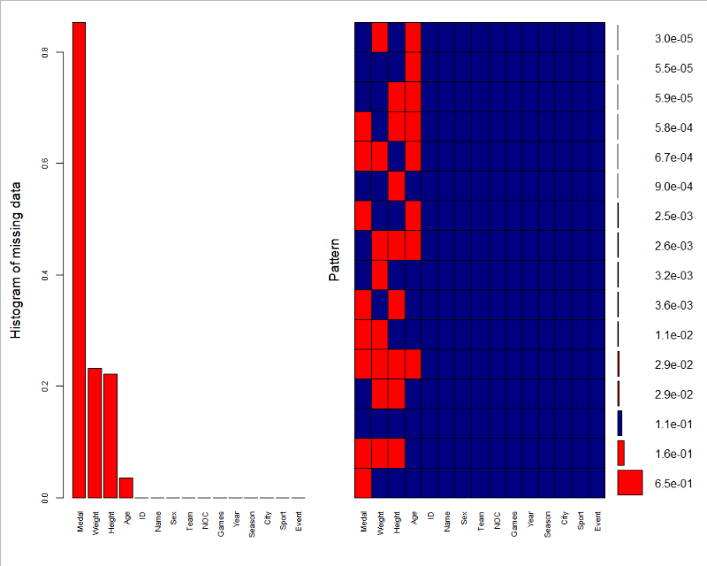

Figure 10: plot showing histogram for variables with missing variables.

The above plot is another visual representation of the missing values within the dataset. For the columns Medal you can see that over 80% of the values are missing values. When researching the dataset in its description the missing values for medal were for athletes that did not win any medals therefore it was listed as a NA. The reason the percentage of NA values is so high in the medal column is simply because there are more losers than winner in the Olympic Games, only a small percentage of participating athletes win medals.

The process of dealing with these missing values was done primarily on R. As the dataset included both Summer & Winter Olympic Games, I created a subset that only included the Summer Olympic games as I am predicting the 2020 Tokyo Summer Olympic Games. I had then split the dataset into males and females using the Sex variable within the dataset. This was done to deal with the missing values for height, weight and age as males. I am also only dealing with the events that took place from 1992 onwards as I believe it is a sufficient amount of data for my predictions. Below is the code snippet used to make this happen for the male data split. The female data uses the same code but with different variable names.

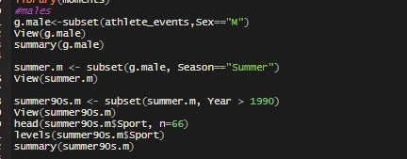

Figure 11: code for splitting data into males

Once the subsets of data were acquired, the next step was to replace the missing values for age, height, and weight with the average values of those columns. The average values were found by using Excel and clicking on the required column, it would then display the average value for that column as seen in the figure below.

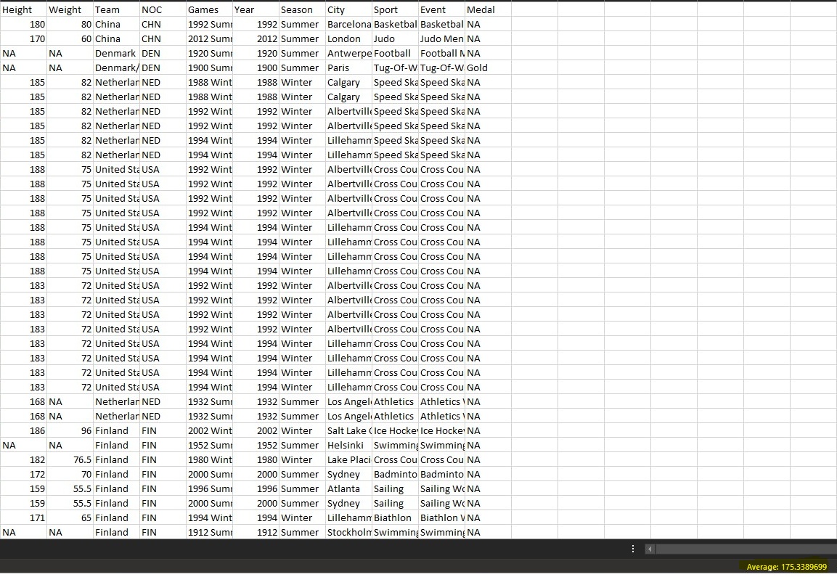

Figure 12: using excel to get the average value for the column

As you can see in the above figure the highlighted value in the bottom right corner is the average value for the height value given by Excel. I then used these values to replace the missing values by using the below code in R.

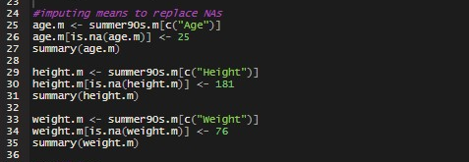

Figure 13: replacing NA values with the average value for the variables

The next step was to deal with the Medal column, which was done in Excel. I decided to replace the words NA, Bronze, Silver & Gold with the numbers 0,1,2 &3 respectively by using the replace function in Excel. Once I did that for both male and female subsets, the use of the rbind function in R to merge the data into one complete dataset and did a check for NA values, the result for that is below. It shows that there are no longer any missing values within the dataset.

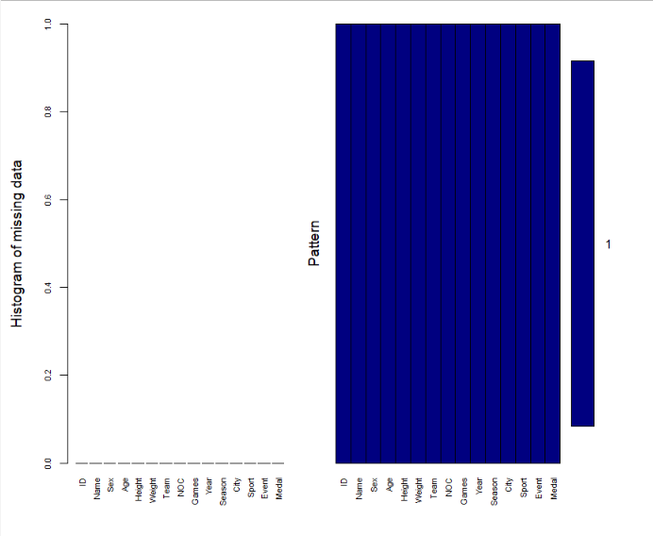

Figure 14: graph showing there are no more missing values

### Data Transformation

In this stage, the goal is to figure out which variables are required for my prediction model and which variables are not. This was done by carrying out data exploration on the dataset in order to help me understand more about the data.

Before I conducted any sort of predictive analysis on my data it was crucial for me to know which variables are best suited for this task. I did this by conducting a correlation test on the data in R. While trying to implement the correlation test in R I learned that not all the variables would be taken in the test as they were factor variables. The only variables that I could use were numeric variables which meant that I could not use half of the variables in the dataset.

The correlation tests consisted of Pearson, Kendall & Spearman tests, the results for the test are below.

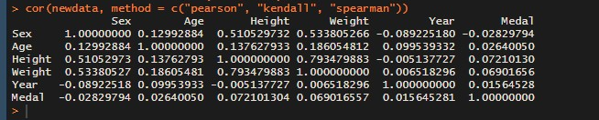

Figure 15: correlation test between numeric values in the cleaned dataset

As you can see in the results the correlation values for the variables Height & Weight are high showing that there is a strong positive correlation between the two variables meaning when the value for height goes up, so does weight. There is also a good positive correlation for sex and height, and sex and weight though not as strong. As the value for female is 1 & male is set as 2, it proves an increase in value for sex would be an increase for height and weight.

The correlation value for Year was very low which indicates that it should be left out of the machine learning model.

It also shows that the correlation values for my dependant variable which is Medal (the value which I am trying to predict) is also low when paired with the other variables. The correlation values are all under 10%. However, they are positive which indicates that there is a relationship between Medal and the other variables. The correlation for Medal and Sex is a negative. I decided to keep the variable Sex for the machine learning model as its correlation result still proves there is a relationship between Sex and Medal.

To give a better understanding for the dependant variable Medal I have provided a bar plot below showing the total number for each medal won by an athlete. (where 0 =”no medal”, 1 = “Bronze”, 2 = “Silver & 3 = “Gold”).

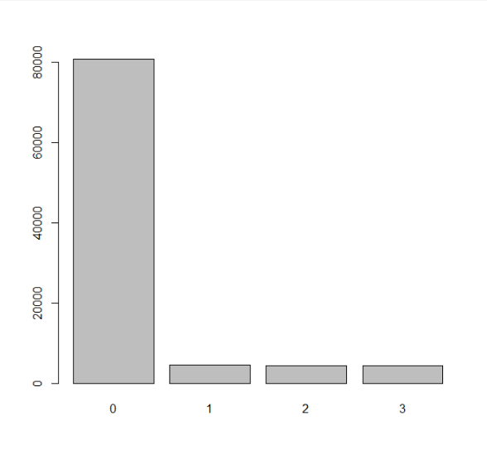

Figure 16: histogram showing data imbalance (0 = No Medal, 1 = Bronze, 2 = Silver, 3 = Gold))

As you can clearly see from the plot above there is a great imbalance within the data for Medal. It is expected as this data consists of Olympic medal winners & losers from the 1992 Summer Games onwards. There can only be 3 winners for each event and the rest of the participants are given no medal.

### Statistical Tests

One of my aims for this project is to see if the population and GDP (Gross Domestic Product) of a country has an impact on the performance of that athlete. I wanted to see if there was a significant difference between developed and developing countries when comparing the medals earned by athletes and their losses. To do this I conducted multiple Mann Whitney U tests between a developed country and a developing country. The reason I ask if GDP statistics influence athletic performance, is because I want to discover the difference between a country which is capable of funding its athletic facilities very well and compare it with one which does not fund its athletic facilities as much. In a study titled, “Who Wins the Olympic Games: Economic Development and Medal Totals” by (Bernard and Busse, 2000) they discuss a countries success at the Olympic Games. They say that ***“Larger countries have a deeper pool of talented athletes and thus a greater chance at fielding medal winners”*** by (Bernard and Busse, 2000)***.*** I want to prove that there is a significant difference in the earnings of medals when comparing developed countries with developing countries. Therefore, I want to include the population and GDP of various countries to discover the trends. In order to select which countries, I would compare I used a density plot which I made in Tableau.

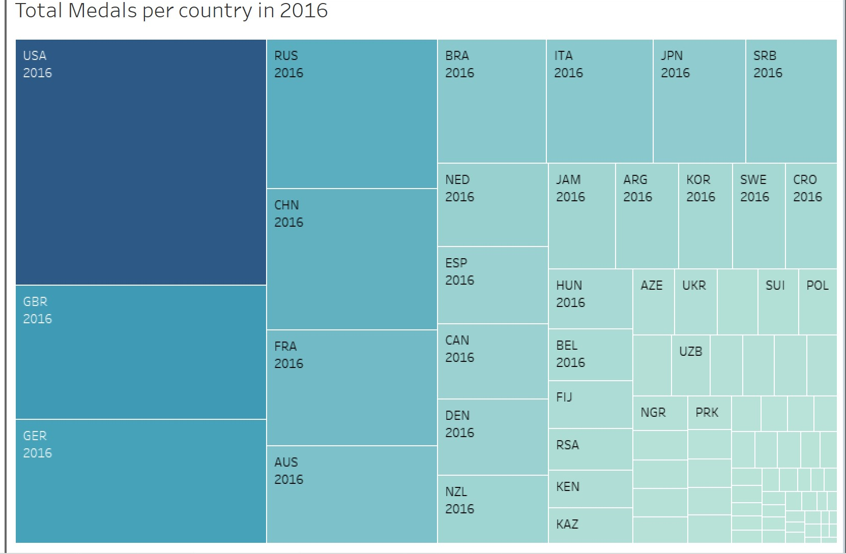

Figure 17: density plot in Tableau showing countries with most medals in 2016

As you can see majority of the medals have been won by developed countries and a very small percentage had been won by developing countries. The best way to compare if there is a difference is to compare the countries that have similar amounts of medals. For the purpose of this test I also have the populations and GDP per capita of each selected country which from a dataset found on Kaggle the sources for the data include the United Nations and the World Bank. In an article by Investopedia which is a reputable source for information’s regarding financing and investing they stated that for a country to be considered a developed country they must “have GDP per capitas of at least $12,000(USD), although some economists believe $25,000 (USD) is a more realistic measurement threshold.” (Top 25 Developed and Developing Countries, 2019). The developing countries selected for these tets all had a GDP per capita of under $12,000 for the year 2016. I conducted the Mann-Whitney U tests in R.

I first conducted a Shapiro Wilks test on the data to determine if it was normally distributed.

Null Hypothesis: H0: The sample Olympic data is normally distributed.

Alternative Hypothesis: H1: the sample Olympic data is not normally distributed.

The alpha value has been set at alpha = 0.05 which I believe is appropriate for this test and will a 5% risk for a Type 1 Error to occur.

Below is the code used to conduct the Shapiro Wilks test and its results:

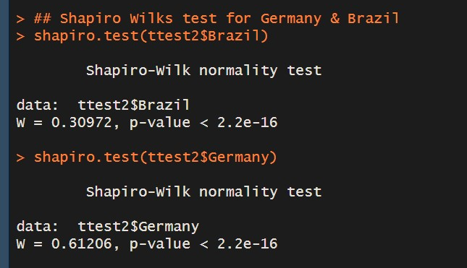

Figure 18: Code & result for Shapiro Wilks test in R

As can be seen in the results the p value is less than the alpha value which I had assigned as 0.05. This proves that the null hypothesis is false, and the alternative hypothesis is deemed to be true. Therefore, the sample Olympic data is not normal. In order to compare the sets of data I will need to conduct a Mann-Whitney U test which is a non-parametric test used for categorical data.

#### Mann-Whitney U test

In this test I will be comparing the results of the 2016 Olympic Summer Games from all participating athletes from two countries. These countries are Germany (A developed country) with a population as recorded in 2016 of 82.193 million people and a GPD per capita (The average income per person) as recorded in 2016 of $42443 & Brazil (A developing Country) with a population as recorded in 2016 of 86.5 million people and a GPD per capita (The average income per person) as recorded in 2016 of $8650. The results of this test will determine if there is a significant difference in the results.

Null Hypothesis: H0: The sample Olympic data is distributed between the two countries.

Alternative Hypothesis: H1: the sample Olympic data is not normally distributed between the two countries.

The alpha value has been set at alpha = 0.05 which I believe is appropriate for this test and will a 5% risk for a Type 1 Error to occur.

Below is the code used in R to perform the Mann-Whitney U test and the result.

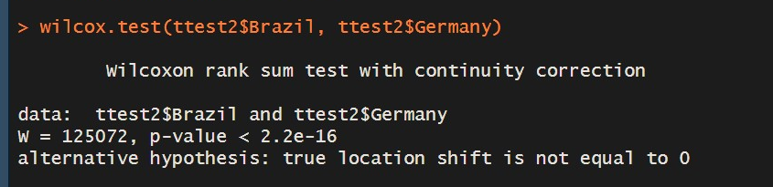

Figure 19: Code & Result for Mann-Whitney U test in R

As can be seen in the results the p value is less than 0. This proves that the null hypothesis is false, and the alternative hypothesis is deemed to be true. Therefore, the sample Olympic data for medals earned by the athletes is not equally distributed between the two countries. This proves that the populations and GDP values for countries does have an impact on the performance of their athletes.

### Which Developing Country has improved the most?

One of my sub-aims was to determine which developing country has improved the most. In order to do this I needed to create a new subset which included the data from the original data set as I needed all data from the first Olympic games which was in 1896 in order to see when the country first participated in the Summer Olympics and what trends I can see from the visualizations. I used both R and Tableau for visualizations.

From my research on the Olympic Table standings it was clear that China was by far the most improved country as they were the only developing country that was consistently at the top of the leader boards. I also chose random developing countries to see if I could find any trends with their medal earnings. Below is the code I used to make this new data set for this task.

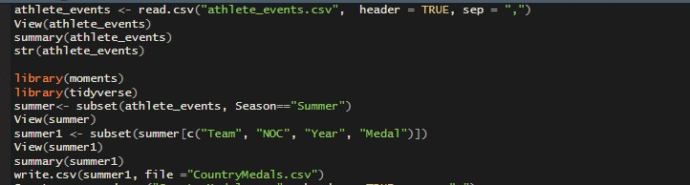

Figure 20: code for creating dataset

To make this dataset I used the original dataset “athlete_events” where I only used columns with no missing values. I used Excel to create a duplicate column for medal where I would assign the medals as numbers as I did previously in the data cleansing process. I assigned No Medal = 0, Bronze = 1, Silver = 2 & Gold = 3.

I made a qplot with my selected countries to show how many medals the countries had in total. I used the socio-economic dataset to find the GDP per Capita figures for the selected countries to ensure they were developing or developed countries.

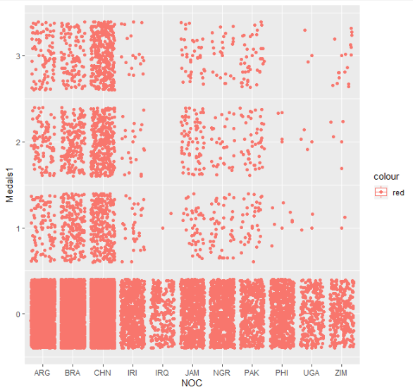

Figure 21: density plot in R comparing total medals for developing countries

As you can see China has a higher density for each medal type when compared to the others. Brazil with the second highest density and Argentina coming third. You can also see that Iraq (IRQ) and Philippines (PHI) have never earned a gold medal.

### Data Mining

For this section of my project I needed to know which machine learning algorithm worked best for my predictive model. As my dependant variable is a factor variable consisting of four factors it is considered a classification problem, I needed to use a multi-nominal machine learning algorithm. I chose two models that I could use and compare against. I chose to use a multi-nominal logistic regression model, ordinal regression model & random forest all in R.

***Multi-nominal Logistic Regression & Ordinal Regression:***

Multi-Nominal Logistic regression is a machine learning algorithm that works with classification data such as the data I am using and trying to predict. This method is deriving from logistic regression which only works on binary class problems. As my dependant variable is classification data this method of logistic regression is best suited.

Ordinal Logistic Regression is another machine learning model that also works with classification data I thought it would be best to include these two types of algorithms to determine which performs best with the data.

To implement this technique and for the models to produce predictions meant that splitting the data randomly was required. This was done by using the below code.

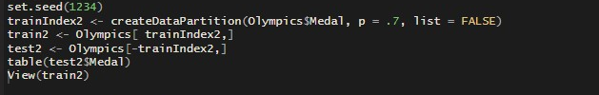

Figure 22: code for creating train and test data

**Evaluation of** **Multi-Nominal & Ordinal Regression:**

After the data had been split the next step was to run both machine learning models and investigate the results that were given. I first ran the ordinal regression model on the cleaned Olympic dataset using all variables, the code and results are below.

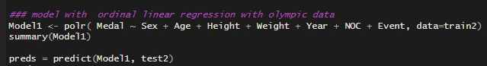

Figure 23: code for ordinal regression model

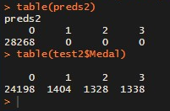

Figure 24: results for ordinal regression model prediction

As can be seen in the results when comparing the results for ordinal regression with the test data, ordinal regression did very poorly as it did not predict any medals. This gave me an indication that it would be best to not use this model.

The results for multi-nominal regression were done using a subset of the Olympic data that only consisted of numerical values the code and results are below.

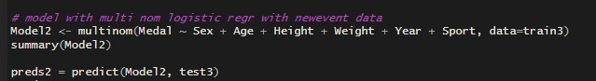

Figure 25: code for Multi-Nominal regression model

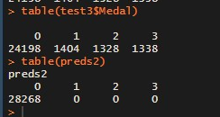

Figure 26: results Multi-Nominal regression model prediction

Looking at the results for the multi-nominal regression and comparing them to the test data shows that this model also done poorly.

Due to these results I needed to find a machine learning model that would provide more accurate results ass the results given by these models were less than satisfactory.

***Random Forest:***

Random Forest is a machine learning algorithm that can be used for both regression and classification problems. The algorithm builds a number of decision trees and then merges them together in order to get the most stable and accurate predictions. The parameters used within Random Forest are ntree**,** mtry and nodesize, ntree is the number of decision trees the algorithm creates, mtry is the number of splits that will take place at each tree node and the nodesize is the value for the size of the node (the bigger the node size, the smaller the size of each decision tree).

In order to prepare for the algorithm, I needed to split the dataset into training and testing datasets this is done in order to help determine the accuracy of the model. I decided to split the data into 70% training and 30% testing, I also created a data split for 80% training and 20% testing to see which sets of data the algorithm would perform best on. I also made multiple variations of subsets with slight alteration in the structure of the data to also which one would perform best. For instance, I created a subset where the dependant variable Sex was a numeric value and one where sex was a Factorial value just to see if there was a difference.

Below is the code that I used to split the datasets into training and test data.

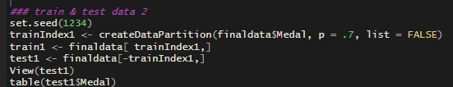

Figure 27: creating new test and train data

I have also provided a table for the test data showing the number of medals in that data frame.

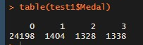

Figure 28: table showing number of medals in test data acting as a benchmark for results

Once I made my data split, I was then able to work on the predictive model.

**Evaluation for Random Forest:**

After the creation my data splits, the making for the models to run them and see what results they produced could occur. Something to note about Random Forest that I discovered while making these models is that the algorithm cannot work with over 63 factor levels. This meant I could not us­e the variables for Country (over 63 countries participate in the Olympics) & Event(There are over 63 events in the Olympics) which I believed would have made a difference even though I couldn’t include them in the correlation tests. I was however able to include the Sport variable.

In total I made 6 different random forest models with different variations of subsets. Two of the models I made performed better than the others. Below is the code used to make these models and the result from running the prediction.

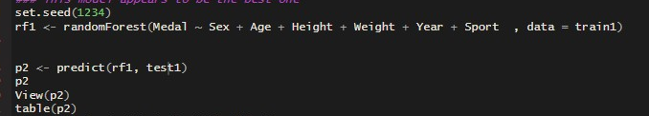

Figure 29: random forest code for prediction model 1

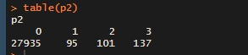

Figure 30: results for random forest for prediction model 1

As you can see from the results the predictions for this model do not match those of the test data in figure 28. In order to understand more about why I got this result I ran a confusion matrix using the caret package in R, the results are below.

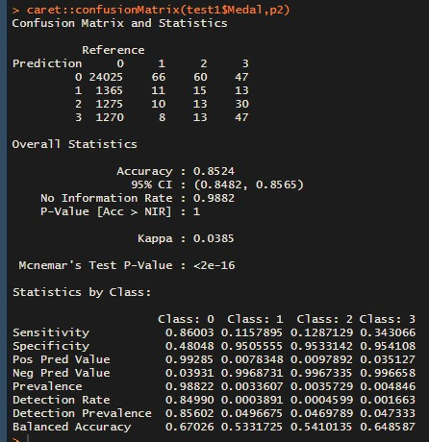

Figure 31: random forest confusion matrix for model1

The first table being shown is the confusion matrix table, this table tells us whether the predicted value is a True Positive (row 1, is a true value), False Negative (row 2, is a true value), True Negative (row 3, is a false value) or a False Positive (row 4, is a false value). In the table you can see that for the number of medals are not all true values and for No Medals (0) over 2500 of the predictions for no medal are false.

However, if you look further down you can see that the accuracy of the model is over 85% accurate. The accuracy of this model was given over 85% mainly due to the data imbalance which I discussed earlier, and you can see the imbalance in figure 16. As there is a very high amount of no medals in this the model assumes that no medal is the preferred value therefore it favours in predicting no medals.

Some more statistics which can be seen are the Sensitivity value which is the percentage value for True Positives, and it is calculates using the formula:

* True Positive/True Positive + False Negative

As you can see the percentage for Sensitivity is very low for the medals Bronze, Silver & Gold.

We can also see the specificity value which is the percentage of True Negative and it is calculated using the formula:

* True Negative/True Negative + False Positive

Here we can see the specificity is very high for the medals Bronze, Silver & Gold. However, the opposite can be said for no medal as its Sensitivity Value is High and its Specificity value is low.

Below, is the code and results for another model & its confusion matrix and I will compare the two models based on their results.

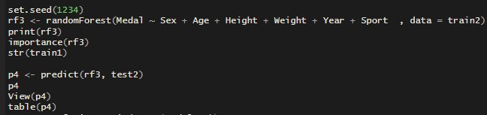

Figure 32: random forest code for prediction model 2

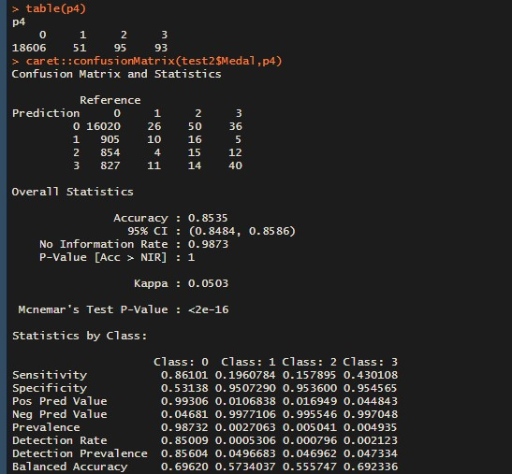

Figure 33: results for random forest for prediction model 1 and confusion matrix

This model is using data split of 80% training and 20% test data which is why the value for no medal (0) is lower than that of model 2. What we can see in that the confusion matrix table has lower values, but the trend is the same. We can also see that the accuracy is identical to that of model 1. However, you can see that there is a very slight improvement for the Sensitivity values for Bronze, Silver and Gold when compared with model 1 but the specificity values are the same. But due to the Sensitivity Value being higher is deemed to have the best performance out of the 2.

There is a method in which you can attempt to improve the prediction for Random Forest models. It’s called parameter tuning, and it basically allows you to change the value of the parameters yourself so that you can attempt get a better prediction. As default random forest has the value for ntree = 500 and the value for mtry = 2. An attempt to tune the parameters by increasing the number of trees and increasing the value for mtry the code for that is below.

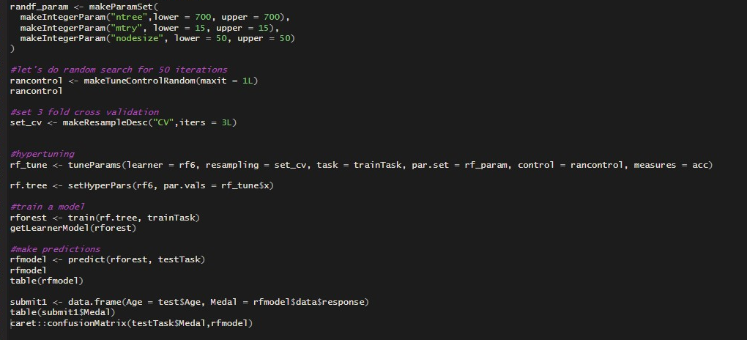

Figure 34: code for parameter tuning

It took approximately 2 hours for Random Forrest to compile this change and a further 30 minutes for random forest to run the model for which the prediction result received was the worst out of all my previous models with no parameter tuning, which also goes to show how well random forest is optimized to the data.

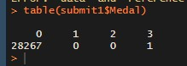

Figure 35: results from parameter tuning

Due to these results. It was apparent that the data I have been using is not suited to predict

### Can an athlete’s attributes predict the outcome for certain sports?

When it was discovered that the dataset did not have the appropriate data to predict which country will win which medal in the events. I needed to take a new approach to how I can solve this. As the dataset had the athlete’s attributes which are the athletes age, height, weight, country of origin and what sport they play, I was interested in seeing if it is possible to predict the outcomes of sports and events based on the athletes attributes. As a means to conduct this analysis, the creation of subsets for specific sports was required. For this, the random forest machine learning algorithm, the multi-nominal logistic regression machine learning algorithm and ordinal regression machine learning algorithm was used to find a difference in results.

For this analysis I wanted to choose 8 different sports, they were by making a plot in Tableau which is shown below.

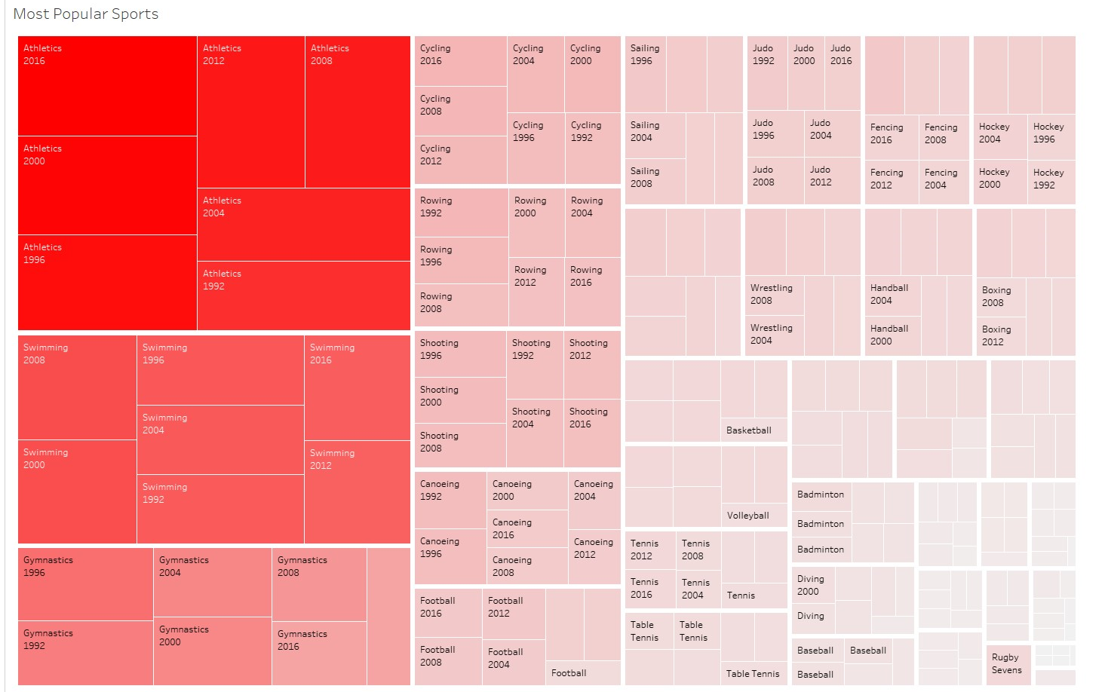

Figure 36: density plot showing sports with the highest participation

The density plot shown in Tableau displays the most populous sport in terms of athlete participation from the years 1992 to 2016. It is very clear to see that Athletics is by far the most populated sport with swimming at second and gymnastics at third. I included these sports in the analyses for this reason. The remainder of the sports chosen were Boxing, Basketball, Diving, Football & Weightlifting, I chose these sports as these are sports, I enjoy watching and have a strong interest in.

Once the subsets of the sports was made, a repeat of the process for running the machine learning algorithms which I had mentioned above on each of the sports, the code for this task has been provided below



Figure 37: code for random forest model for athletics

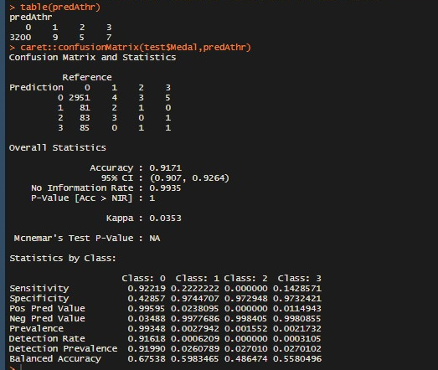

Figure 38: results and confusion matrix for athletics

After running the random forest model again, encountered the same issue that was discovered in my first findings. The accuracy is high, however that is once again due to the data imbalance. The sensitivity values are also very low for the medal classes.

I then ran the multinomial and ordinal logistic regression models to see if could get any better results.



Figure 39: multi-nominal model for athletics

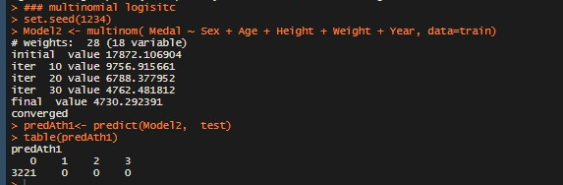

Figure 40: results for multi-nominal model



Figure 41: code for ordinal regression model for athletics

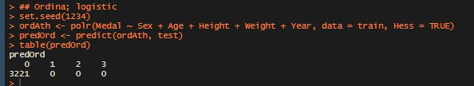

Figure 42: results for ordinal regression model

The results from both models came out worse than the random forest model. I wanted to see if the results would be different if selecting the top performing countries and make a subset of the athletic data including only those countries. This was done by making a plot in R with the package ggplot which I have provided the code and graph below.

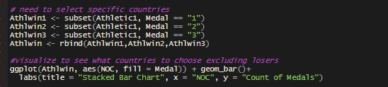

Figure 44: code for making ggplot

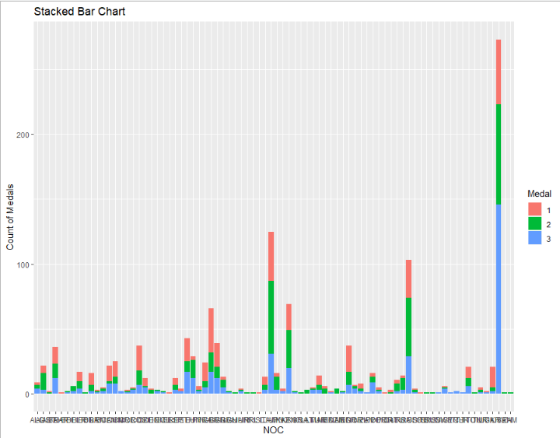

Figure 45: ggplot showing most successful countries in athletics

It is difficult to tell which countries are the most successful however I was able to determine the most successful countries by expanding the plot in R. You can also see from this graph the amount of medal winning countries that participated in athletic sports. Looking at the amount of countries on this graph it can be determined that majority of the participating countries would find success in athletic sports at some stage in their participation.

Another sport worth investigating was basketball. When initially running the machine learning models, poor results were received as was with athletics. The top performing countries were selected and a subset made for the basketball data including only those countries.

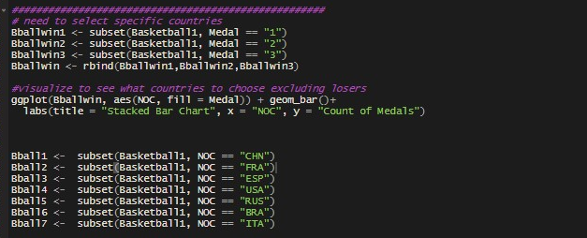

Figure 46: code for ggplot for basketball

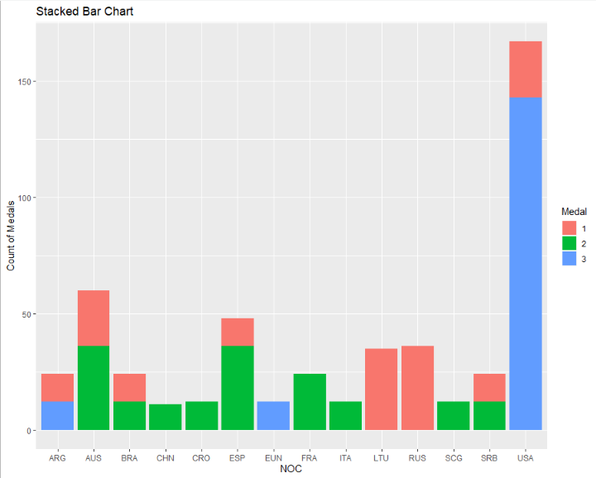

Figure 47: ggplot showing most successful countries in basketball

It was a lot easier to see the countries in the plot for basketball as there were fewer countries that found success in this sport.

Once I had created the subset for Athletics and Basketball, I ran the machine learning models on them both to determine if it was feasible to conduct the analysis this way for the remaining sports.

### Time Series Forecasting

One of my main aims for this project was to predict which country will come 1st, 2nd & 3rd in the 2020 Olympic Games. To do this I needed to look at the table standings for the previous Summer Olympic Games. These tables were available to view on Wikipedia. For the forecasting I needed to choose the countries that placed top 3 consistently and I found those were the USA, Russia & China. I also decided to add other countries that performed very well in previous Olympics such as France Germany & Great Britain. Furthermore I also added the country Japan as they were supposed to host the 2020 Olympics in Tokyo so I was intrigued to see what results I would get for the host country, I also added Ireland as I live here and I hoped to see some improvement as we didn’t in win any medals in 2016.

As I had gathered the countries, I was going to use I now needed to create a new dataset using the cleaned data. I did this on Excel using the filter function as it allowed me to see the total number of medals just by clicking the column after I filtered through the country needed and for the years I used I found this process more efficient than using R.

To conduct my time series analysis, I used both R and Tableau. While working on Tableau I discovered that I cannot forecast data that is spread out in 4-year intervals.to combat this I changed the years which initially ranged from 1992 – 2016 and assigned them the numbers 1-7 accordingly, I then assigned the numbers as years (so that Tableau would think they were years) and the forecasting worked. The results are below.

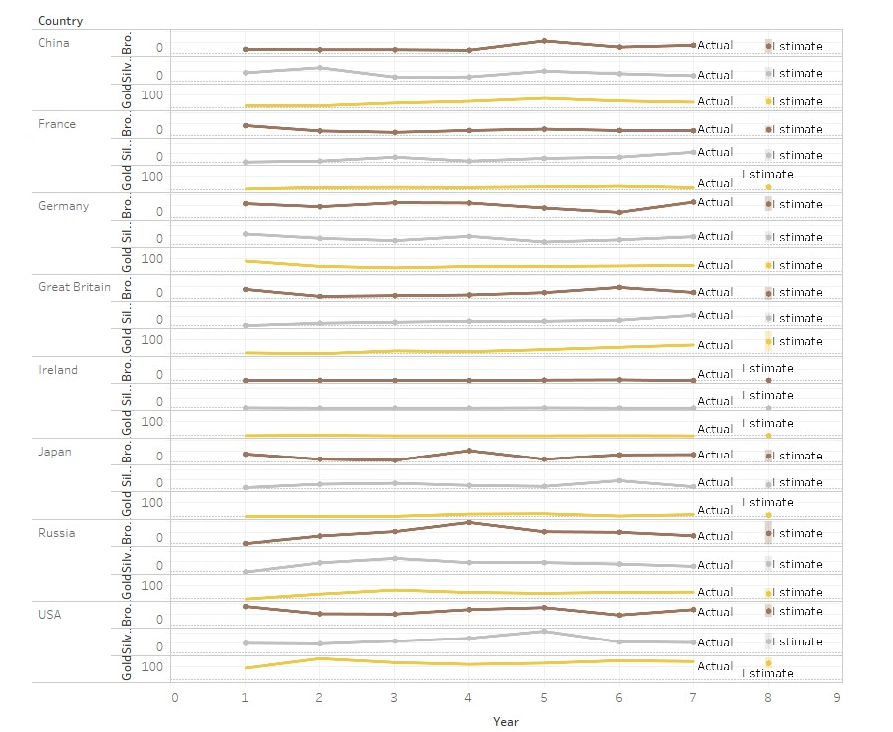

Figure 48: forecast predictions for 2020 in tableau

In order to confirm these results I also conducted a time-series analyses on R using the same data however unlike tableau the ‘forecast’ package I used in R was able to deal with data that had 4 year intervals. Unfortunately, before I could do the forecasting in R I needed to change the dataset format from a data frame into a time series format. This was easier said than done, after 5 minutes browsing, I found a resource which told me to use the package ‘tsbox’ to deal with such a task. Below is the code I used for converting the data into a time series format and the forecasting.

Also, in the code snipped is the steps taken to do a time series analysis this was done after converting the data format into time series. These steps are:

* Visualize the time series in order to determine the type of trend you are expected to see.
* Make the time series data stationary, this is done so that the statistical properties of the data do not change over time.
* Finding the optimal parameters to get the best result
* Building the Arima Forecasting Model
* Make the prediction

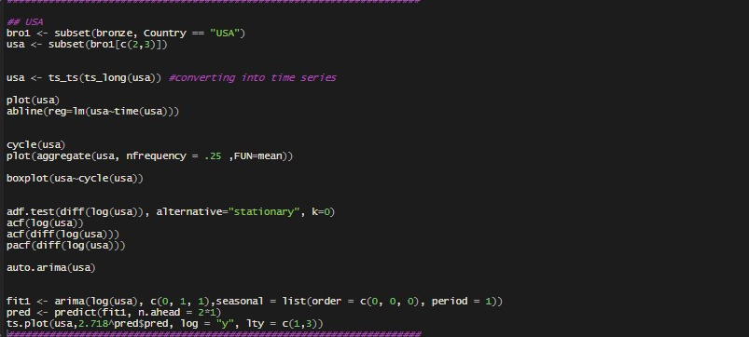

Figure 49: code used for time series in R

The forecasting model being used in R is Arima. It stands for Auto Regressive Integrated Moving Average. This *model “‘explains’ a given time series based on its own past values, that is, its own lags and the lagged forecast errors, so that equation can be used to forecast future values. “*(Prabhakaran, 2020). This model is based on a linear regression model.

The auto.arima function is used build the best model and gives an output with a predicted value and the parameters used for it.

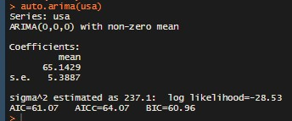

Figure 50: output from auto.arima function

The given parameters were used which in this case was the columns (0,0,0) in an effort to get the best result.

# Results & Conclusions

## Mann-Whitney U Tests

After receiving the result for the first Mann-Whitney U test in R, the testing continued on the other selected countries. As mentioned before the developing countries selected had a GDP per Capita under the value of $12,000. When conducting these tests, the use of the same principles of null and alternative hypothesis was used.

Null Hypothesis: H0: The sample Olympic data is equally distributed between the two countries.

Alternative Hypothesis: H1: the sample Olympic data is not equally distributed between the two countries.

The alpha value has been set at alpha = 0.05 which I believe is appropriate for this test and will a 5% risk for a Type 1 Error to occur.

Below are the results for the remaining tests.

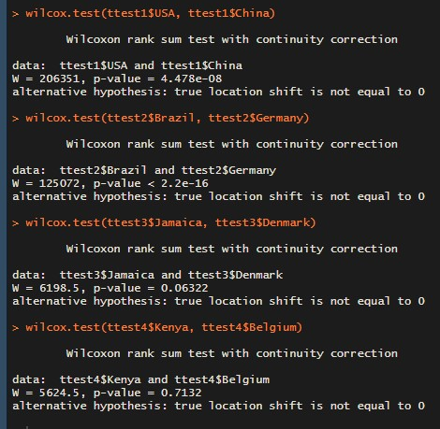

Figure 51: Results for remaining Mann-Whitney U tests proving there is a significant difference between developed and developing countries performance at the Olympics.

**Conclusion:**

From viewing the results of the remaining tests when comparing the developing countries against the developed countries it can be observed that the null hypothesis is rejected in the tests as the p-value is not equal to 0. This deems the alternative hypothesis true, meaning the distributions between the compared sets of data are not equal. This proves that a countries socioeconomic factors does have a role to play in the performance of a country at the Olympic Games.

## Most Improved Developing Country

After viewing the qplot it was clear that china had advanced the most in terms of medals won. I made a ggplot in R to show how China had accumulated these medals over time.

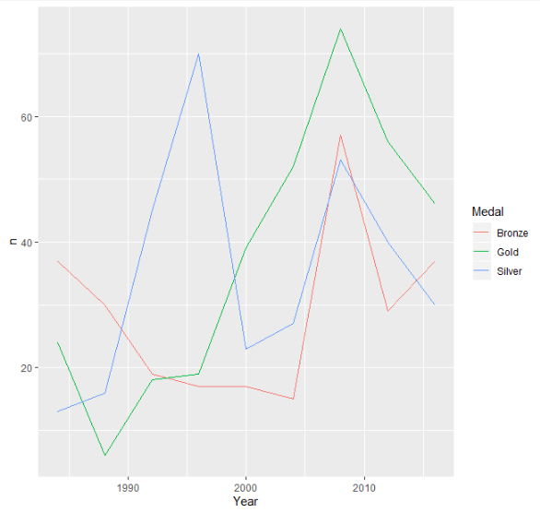

Figure 51: plot in R for medals won by China

The graph in R did not display as much information as one would prefer therefore the same visualization was made in Tableau.

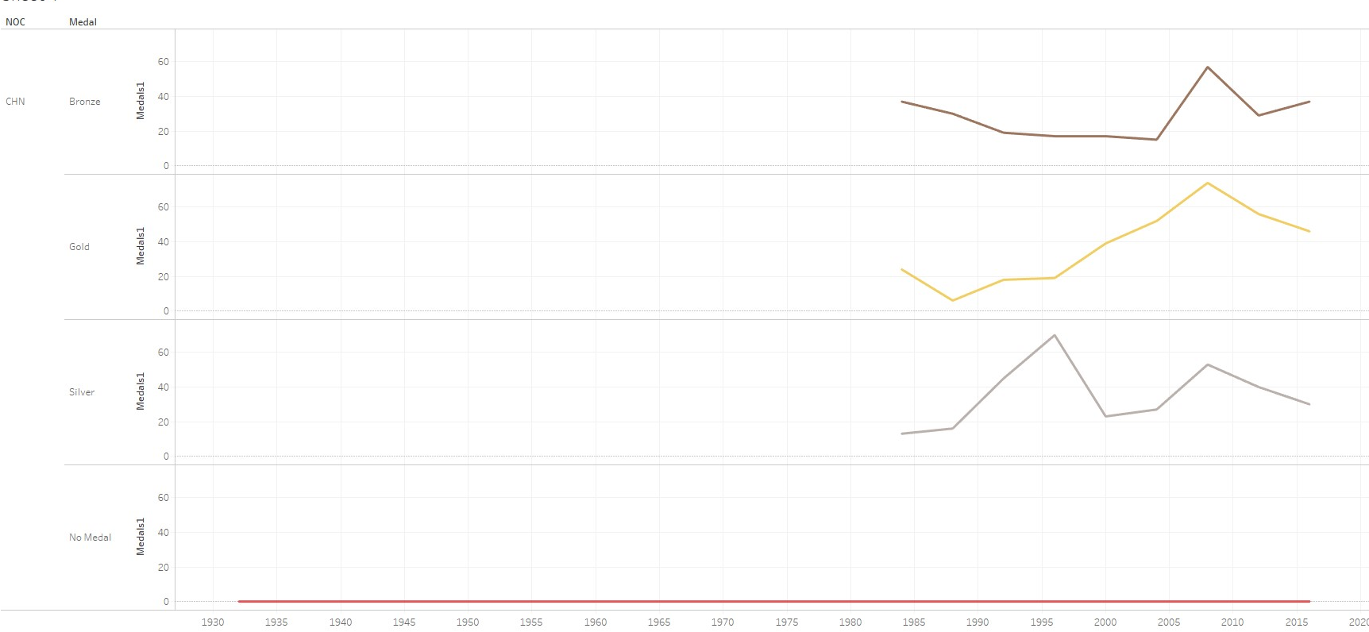

Figure 52: plot in Tableau for medals won by china

From looking at this visualization you can see the Chinas first appearance at the Olympic games was in 1932 and they did not win any medals until 1984. We can also see that their highest medal count occurred in the 2008 Olympic Games where China was hosting the games in Beijing.

After researching I discovered that the reason had not won any medals until 1984 is due to political reasons. For instance, China did not attend the 1964 Olympic games as they were a member of the organization GANEFO (Games of the New Emerging Forces) created in 1962. This organization consisted of countries that at the time were referred to “emerging nations” (GANEFO, 2020) to counter the Olympic Games. As this organization was against the Olympic Games, China did not attend any Olympic Games until the end of the organization in 1967. However, when examining the medal table for the second GANEFO Games in 1967 China came first with a total medal count of 199, proving that China has always been an athletically capable country.

China also boycotted the 1980 Olympic Games in Moscow; this was in protest to the then former Soviet Union and their invasion of Afghanistan. China was not the only country that boycotted the 1980 games, the USA, Canada and a number of other countries also participated. It was due to the “Soviet violations of human rights” (1980 Summer Olympics boycott, 2020) in Afghanistan.

***Conclusion:***

Due to China being absent in the early Olympic Games but still being capable of performing well in other athletic events it makes sense that once China reintroduced themselves to the Olympics, they were set to win medals. As a developing country performing in the top of the leader boards in the last three Olympic Games this is an impressive feat. This also once again proves *“Larger countries have a deeper pool of talented athletes and thus a greater chance at fielding medal winners****”*** (Bernard and Busse, 2000)***.***

## Can an athlete’s attributes predict the outcome for certain sports?

After receiving promising results after running the machine learning models on the new subsets. The code and results for athletics are below.

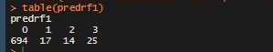

Figure 53: random forest result for new subset in athletics

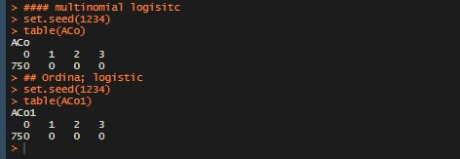

Figure 54: multi-nominal and ordinal result for new subset in athletics

From viewing the predicted value for the test data on athletics you can see that the random forest model did a better job than before, this could be because of less imbalanced data. When looking at the multinomial and ordinal models once again it did not predict any bronze, silver, or gold medals. Overall, even with the results for the random forest model being better than the original it still wasn’t good enough to prove that an athlete’s attributes can be used to predict the outcome of athletic sports events.

Moving on to run the same analysis on the basketball data. A correlation test was conducted on the new basketball subset to see if there was an improved correlation between the variables and the dependent variable Medal, which I have provided below.

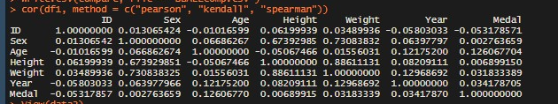

Figure 55: correlation test for new subset data for basketball

The results of this correlation test have proved promising for me as all variables had a positive correlation with the dependent variable Medal except for ID. Although the positive correlations are small values it proves that an increase in the variables results in an increase in Medal.

Here I found a more positive result when running the machine learning algorithms, which I have provided below.

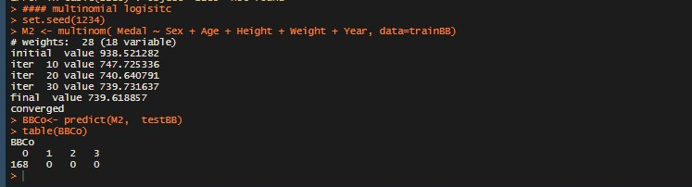

Figure 56: results for multi-nominal regression model for basketball subset

As can be seen, once again the multinomial logistic model failed to produce a prediction for bronze, silver and gold medals. The predicted values against the test data from the random forest model gave a more successful result which I have provided below.

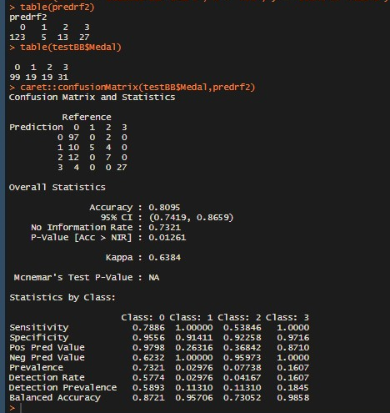

Figure 57: results for random forest model and confusion matrix for basketball

From these results for basketball, they are a lot closer to the test data. The values predicted for the number of bronzes, silver and gold are very close to the original number in the test data. When examining the confusion matrix, the prediction is given an accuracy of almost 81% and note that the sensitivity figures are higher than the previous model for basketball.

***Conclusion:***

In conclusion, it is possible to predict the outcome for basketball in the Olympics using the data from the athlete’s attributes.

The results given by the basketball predictions proved that this method for prediction can provide more accurate prediction. I have provided a screenshot of an excel file where I used a cbind function to merge the predicted column with the test data.

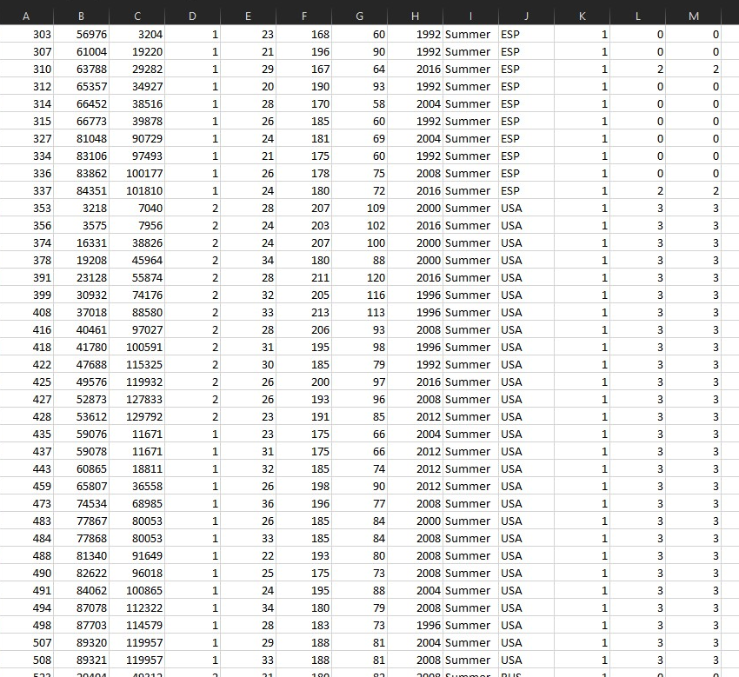

Figure 58: excel sheet for comparison of new predicted data against test data

From observing the predicted result (column M) with the test data (column L) it shows that the model has learned that the country USA has a high relationship with getting gold medals which is a good indication that the USA will get gold in basketball in the next Olympic Games.

Due to this success I repeated this process on the remaining sports.

What I found is that for the sports Athletics, Weightlifting, Gymnastics & Boxing you cannot use and athletes’ attributes to predict what medals the countries would win in those sports. For the sports Basketball, Diving, Swimming & Football you can use the athlete’s attributes to predict which countries would win medals in those sports.

## Time Series

The results for my forecasting method used in both tableau and R were successful. I exported the results from Tableau into an Excel file so you can see what the predictions were.

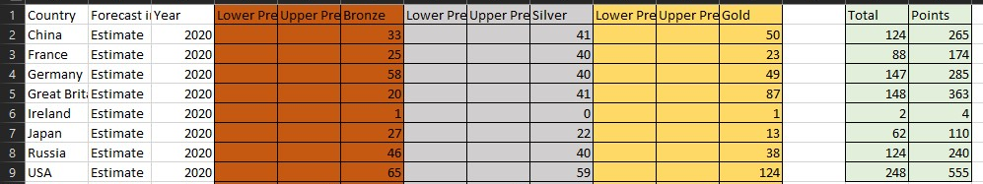

Figure 59: table in Excel showing predicted number of medals and points for the countries

As the dataset is data consisting of every athlete that took part in the Olympic games since 1992 the medal count is for every athlete that earned a medal which is why these figures don’t match the official figures on the Olympics medal table. What this means is that if a country wins Gold, Silver or Bronze for a team sport it will count each medal individually for each team member in the team. For example, if a country gets silver in basketball, because there are 12 players in a basketball team the country will have 12 silver medals added to the total whereas the official count for the Olympics would be 1 Silver medal in basketball not 12. When you look at countries like the USA which has a very high medal count when compared to the others it is very evident that the USA participates in the majority of team sports and dominates the other countries in those sports which explains why the USA has such a high medal count. It also further proves the point which had previously been referred to *“Larger countries have a deeper pool of talented athletes and thus a greater chance at fielding medal winners”.* (Bernard and Busse, 2000)*.*

***Conclusion:***

Going back to the predicted results it is evident that the USA will win the most medals per athlete. However, the total of 248 for 2020 is less than the total medals earned in 2016 which was 263. I added a weighted point system for each medal so we can see the positions of each country (Bronze = 1 point, Silver = 2 points & Gold = 3 points). From this you can see once again that the USA will win 1st in terms of points. When examining the results of the remaining countries you see that Great Britain has a high chance of coming second with a total of 148 medals and 363 points, Germany is predicted to get 3rd with 285 points. The battle for fourth is between China & Russia both predicted to win equal number of medals at 124 but when looking at the points China takes 4th. as they are predicted to win more higher weighted medals than Russia.

The prediction for the host country Japan is very impressive as well with a total of 62 medals. Out of all the predictions the one I want to come true the most is for Ireland, one Bronze and one Gold I would be over the moon if we get that result! It will also be interesting to see where France and Germany will end up in the 2020 leaderboard.

As mentioned before R was used to conduct a forecast to see if the results matched and the majority of them did such as this one for the forecast for Bronze medals to be won by the USA.

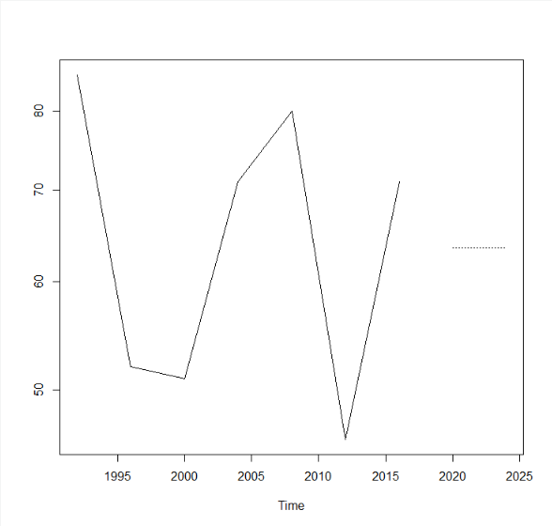

Figure 60: time series forecast for predicted number of bronze medals for the USA

It is difficult to tell the exact number in the plot given by R but it does line up with 65 on the graph which is the same as the value given by tableau. While the majority of the outputs matched those given by Tableau there were a few that did not such as the predicted value for Silver medals for Russia is predicted to be 40 as seen on the result by Tableau but the Arima forecast used in R predicted less than 40.

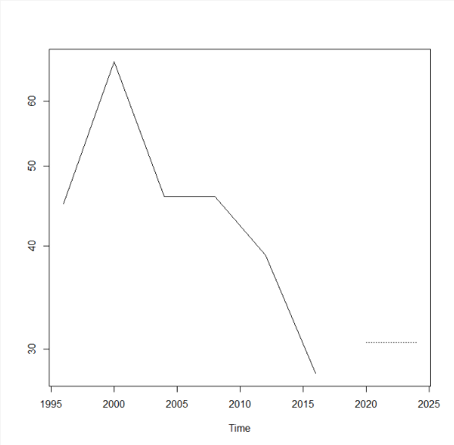

Figure 61: time series forecast for predicted number of silver medals for Russia

As seen in the plot outputted by are the predicted value for total Silver Medals earned by Russia appears to be less than 35.

The difference in results does prove that you should not rely on predicted values, one of the values could be right or they could both go wrong. When assessing predictions its best to take the result with a grain of salt as there really is no prediction for an anomaly to occur such as an injured athlete or even a cancelled event. Similar to how nobody predicted that the Corona Virus outbreak would occur in 2020 and ruin everyone’s summer. However these results are a good indicator of what to expect from these countries and if they can deliver on these predictions and for that I am excited to see if some of these predictions were right and if not how far off were they

# Further Development or Research

There is potential for this project to be extended into an application which will display the predictions for all events and comparisons of different countries for both Summer and Winter Olympic Games.

From working with this data, I have learned that the variables in this data are not suited to predict which country will win medals or lose in what event. If I were to research further into this problem I would need to find or create an Olympic dataset that does not consists of the athletes data but one that has the medal earned for each event for each country and includes the Socio-Economics of each participating country as data such as population and GDP statistics are more relevant for tasks such as predicting outcomes. It would also be crucial to deal with the imbalanced data that would be present as it will affect the accuracy for predictions

Currently the Machine Learning models are using previous athlete’s data to predict the outcome of future events. The problem with this is that it is highly likely that the same athletes will not take part in the next Olympic games as they may have retired or due to some unpredictable circumstances.

Therefore, I would like to develop a solution using the socioeconomics of a country as it gives a deeper insight into how the funding of athletes plays a role in winning medals. The dataset will also need to consist of the official medal count for the country and not per athlete.

Once the desired dataset has been created or obtained, the same techniques can be used such as the random forest model to predict the outcomes.

A restructure of the dataset to a time series forecast can be implemented for use of an arima forecast to predict the outcome for the events.

# References

* Donges, N., 2019. *A Complete Guide To The Random Forest Algorithm*. [online] Built In. Available at: <https://builtin.com/data-science/random-forest-algorithm> [Accessed 21 July 2020].
* Bernard, A. and Busse, M., 2000. Who Wins The Olympic Games: Economic Development and Medal Totals. SSRN Electronic Journal, [online] Available at: <https://www.nber.org/papers/w7998.pdf>.
* Gough, C., 2020. Tokyo 2020 Advertising And Sponsorship Revenue Loss Due To Coronavirus 2020 | Statista. [online] Statista. Available at: <https://www.statista.com/statistics/1104150/coronavirus-revenue-loss-olympics-ad-spend/> [Accessed 31 July 2020].
* Graham, M., 2019. NBC Says It Has Topped $1 Billion In National Ad Sales For 2020 Summer Olympics. [online] CNBC. Available at: <https://www.cnbc.com/2019/12/10/nbc-says-it-topped-1b-in-national-ad-sales-for-2020-summer-olympics.html> [Accessed 31 July 2020].
* En.wikipedia.org. 2020. 1980 Summer Olympics Boycott. [online] Available at: <https://en.wikipedia.org/wiki/1980_Summer_Olympics_boycott> [Accessed 1 August 2020].
* En.wikipedia.org. 2020. GANEFO. [online] Available at: <https://en.wikipedia.org/wiki/GANEFO> [Accessed 1 August 2020].
* Investopedia. 2019. Top 25 Developed And Developing Countries. [online] Available at: <https://www.investopedia.com/updates/top-developing-countries/> [Accessed 1 August 2020].
* En.wikipedia.org. 2016. 2016 Summer Olympics. [online] Available at: <https://en.wikipedia.org/wiki/2016_Summer_Olympics> [Accessed 3 August 2020].
* En.wikipedia.org. 2012. 2012 Summer Olympics. [online] Available at: <https://en.wikipedia.org/wiki/2012_Summer_Olympics> [Accessed 3 August 2020].
* En.wikipedia.org. 2008. 2008 Summer Olympics. [online] Available at: <https://en.wikipedia.org/wiki/2008_Summer_Olympics> [Accessed 3 August 2020].

**Literature review:**

* C. Thirumalai, S. Monica and A. Vijayalakshmi, "Heuristics prediction of olympic medals using machine learning," 2017 International conference of Electronics, Communication and Aerospace Technology (ICECA), Coimbatore, 2017, pp. 594-597.
* Hoffmann, M., Moeller, T., Seidel, I. and Stein, T., 2017. Predicting Elite Triathlon Performance: A Comparison of Multiple Regressions and Artificial Neural Networks. *International Journal of Computer Science in Sport*, 16(2), pp.101-116.
* Maennig, W. and Vierhaus, C., 2016. Winning the Olympic host city election: key success factors. Applied Economics, 49(31), pp.3086-3099.

**References for code:**

Parameter Tuning:

* <https://www.analyticsvidhya.com/blog/2016/08/practicing-machine-learning-techniques-in-r-with-mlr-package/>

Visualizations in R:

* <https://www.r-bloggers.com/7-visualizations-you-should-learn-in-r/>

Changing data format into time series:

* <https://stackoverflow.com/questions/29046311/how-to-convert-dataframe-into-time-series>

Time Series in R:

* <https://www.analyticsvidhya.com/blog/2015/12/complete-tutorial-time-series-modeling/>

Machine Learning in R:

* <https://www.youtube.com/watch?v=q1RD5ECsSB0&list=PLk8qEDmb_odwt8Z6sIKO6egzgRuUMaHwq&index=2&t=0s>
* <https://www.youtube.com/watch?v=dJclNIN-TPo&list=PLk8qEDmb_odwt8Z6sIKO6egzgRuUMaHwq&index=4&t=739s>

# Appendix

## Appendix A: Definitions, Acronyms, and Abbreviations

**GUI:** Graphical User Interface, this is the visual aspect of the project, and in my case a dashboard like tableau

**AI:** artificial intelligence, a computer programme that is capable of making its own decisions.

**Dataset:** this is a file, a body of data taken from a subject that consists of numerical values and categorical values.

**Olympic Games:** a major and significant athletic event that occurs every 4 years where countries from all over the world participate to compete against each other in various different sporting events.

**Machine Learning:** this is a type of artificial intelligence; it is an algorithm that can learn through experience

**Random Forest:** a method of machine learning algorithm used to work on classification & problems

**Multi-nominal Logistic Regression:** another machine learning algorithm used to work on classification & problems derived from logistic regression

**Ordinal Regression:** machine learning algorithm used to work on classification

**Tableau:** a tool used for data visualization that aids in the understanding of data by providing the user with intuitive and interactive graphs and charts.

**Time Series Analysis / Forecasting:** a method used to extract trends in data and shows insightful statistics such as predicted values for a future date.

**Shapiro Wilks Test:** a statistical test used to check for the normality of data

**Mann-Whitney U Test:** a statistical test used to compare to sets of data against each other in order to determine if there is a significant difference between them.

**Excel:** this made by Microsoft that allows you to see spread sheet data and datasets and also has tools that allow for calculations and visualizations.

**CSV:** a type of file format where information from databases and spreadsheets are stored.

**Confusion Matrix:** this is a table that allows the visualization of an algorithms performance

**Correlation Test:** this is a test conducted to determine relationships between variables in a dataset.

**Parameter Tuning:** this is the adjustment of parameters within a machine learning algorithm in an attempt to get better results.

**NA:** Values in a set of data that are not available; also known as missing values

## Appendix B: Literature Review

**Predicting the 2020 Summer Olympic Games and Analysis on Athlete Performance: A Literature Review**

**Abstract:**

***This project was conducted with the intention to predict the wining teams for the 2020 Tokyo Olympics. The Olympic Games is a major global athletic event that takes place every 4 years since 1896 when the first Olympic games were held in Athens, Greece. In the Olympics Athletes from across the globe participate in the event and represent their country and to prove that they are the best of the best on a global scale.***

***The goal of my project will be to inform the general public and the participating teams in the Olympic Games of what the predicted outcome of the Games will be. While also seeing if the socio-economic factors of a country impacts its performance in the games.***

***With the findings I intend to visualize it on an intuitive dashboard that will show the viewers the various predictions for the events.***

**Keywords – Olympics, Outcome, Socio-Economic, Predictions**

**Introduction:**

The purpose of this project is to predict the winners of the 2020 Olympic Games, by winners I mean which country will be coming 1st, 2nd & 3rd in the Olympics. This will be done by counting the predicted number of total medals won by the countries who are most likely to win. There are factors that play into this such as population size as the more people there are in a country the more likely it is for the country to participate in every event thus allowing the country to win more medals. Socio-Economics also play a factor in this as the amount of disposable income per capita can have an impact on the type of training the athletes receive, GDP can also have an impact as the amount of income available for government expenditure, it may not go into funding athletic centers as much when compared to other countries.

With this aim in mind, I will be building models for the predictions which will be Multi-nominal Logistic Regression, ordinal regression, Random Forrest, Pearson Correlation test and more.

**Related Work:**

In the paper “Heuristics prediction of Olympic medals using machine learning” written by [Chandrasegar Thirumalai](https://ieeexplore.ieee.org/author/37086106318); [S Monica](https://ieeexplore.ieee.org/author/37085983184); [A Vijayalakshmi](https://ieeexplore.ieee.org/author/37086303727). The authors talk about the use of the different methods of correlations that they used in with their data which is on the Olympics. They are only using the medals from the 2012 Olympic games. They go through their use of the Spearmen and Pearson correlation and coefficient on the same data set as mentioned before. They want to see id they can find any relationship between two categorical factors and a constant factor. In their dataset they also include GDP numbers for a select number of countries.

In their analysis they discover that there is a high correlation between the total amount of medals and the GDP of a country.

Where my project differs is that I will be looking at more variables and will see if there is a correlation between the medals and other variables such as Age and Height as well as countries. This will help me in my prediction to see which variables are worth using for my prediction for the winners as well as my analysis for GDP against a team’s performance.

2.

In an academic journal titled “Predicting Elite Triathlon Performance: A Comparison of Multiple Regressions and Artificial Neural Networks” written by HOFFMANN, M., MOELLER, T., SEIDEL, I. AND STEIN, T. They are testing two German triathletes of the elite level as they wanted to predict their race time using a multiple linear regression model.

The regression model was used to *“identify performance-relevant parameters and predict overall race times” - (Hoffmann, Moeller, Seidel and Stein, 2017)* of the German athletes. Their regression model gave a result stating the best variables to use in order to predict the race times.

This study differs from my project as in this study HOFFMANN, M., MOELLER, T., SEIDEL, I. AND STEIN, T. are looking at the reported results of the athletes body functions such as blood lactate and respiratory rate as well as the physical features of the athletes such as shoulder and pelvis width. However, they are using the model to predict the times the athletes will get using these factors as variables.

I have taken inspiration from this idea and will implement a multiple linear regression model to predict which team will win how many medals in particular events such as athletics and aquatics. I can use variables such as age and height and see if the regression model suggests using these variables in order to predict the winners.

3.

While reading on an academic journal titled “Winning the Olympic host city election: key success factors” by Wolfgang Maennig and Christopher Vierhaus, I saw how they used a logistic regression model to predict which city will host the 2020 Olympic Games. The paper was published in 2016 before the hosting city had been announced by the Olympics Committee. Their logistic regression model included Olympic, economic, and political factors which were significant for the prediction for which city will win the bid for hosting the 2020 Olympic Games.

In their analysis they found that there was a high correlation coefficient between hosting cities and metropolitan area population, these cities have populations over 2.5 million which appeared to be favorable for hosting the Olympic games when compared to cities with a population under 2.5 million.

In their conclusion, the regression model reported that Tokyo, Japan had the highest probability to be the next city to host the 2020 Summer Olympic Games. As we now know this is now true as the 2020 Olympics will be hosted in Tokyo. The regression model gave Tokyo a very high probability of over 74%. In second place for the predicted bid was Istanbul with over 24% probability.

In my project my I will use a logistic regression model to predict the probability for which country will win how many medals in events such as athletics, swimming etc. The model can even tell me which countries are more likely to win gold, silver & bronze medals in total.

## Appendix C: Code and results

Below I have provided the code used to see if an athlete’s attributes can be used to predict the outcome of some sports.

DIVING

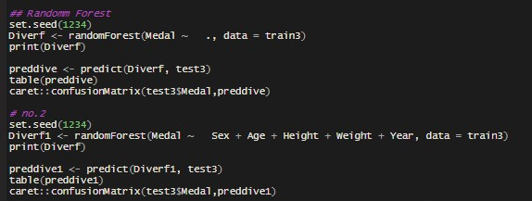

Figure 62: code for random forest model on diving sport

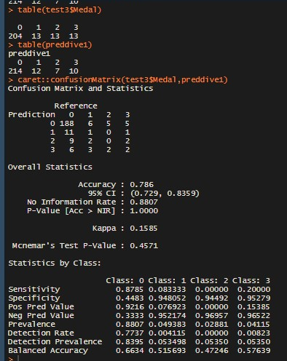

Figure 63: Here the results for diving show a good prediction when compared with test data

BOXING

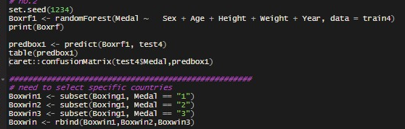

Figure 64: As result was bad when compared to test data, I selected the countries to see if there was an improvement.

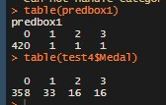

Figure 65: Result after selecting countries, slightly better but not great

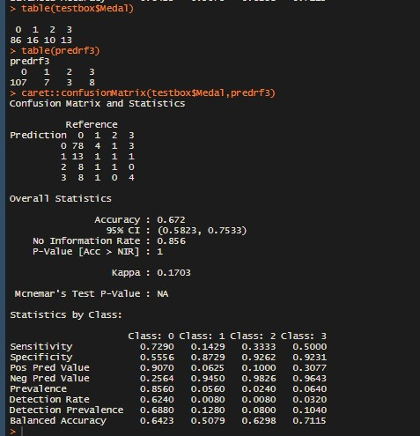

Figure 67: results and confusion matrix for random forest model on the sport boxing

GYMNASTICS

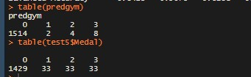

Figure 68: Results for gymnastics when compared to test data

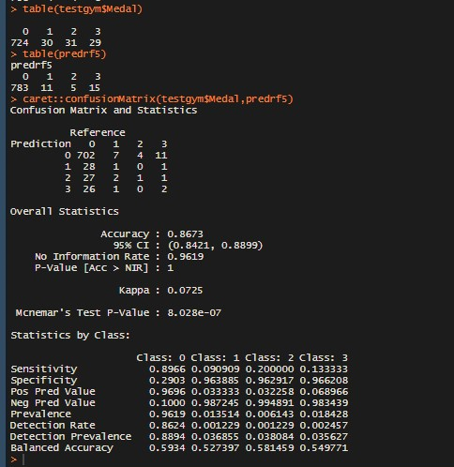

Figure 69: Results after selecting countries using the same process

SWIMMING

Results when compared to test before country selection

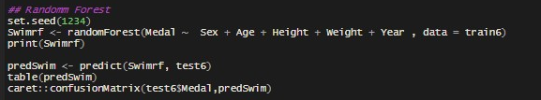

Figure 70: code for random forest model on swimming sport

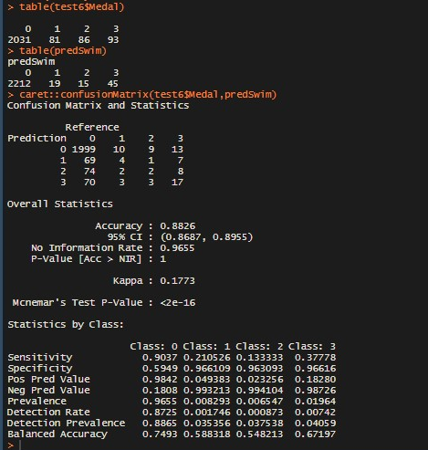

Figure 71: Results after running code in figure 70 with confusion matrix

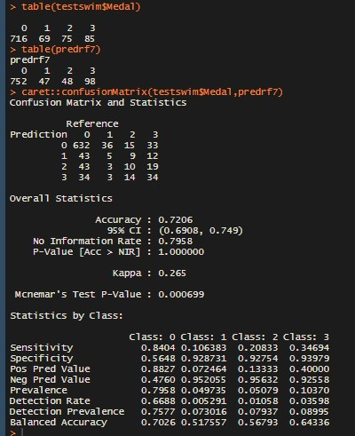

Figure 72: results after selecting country and confusion matrix for swimming

FOOTBALL

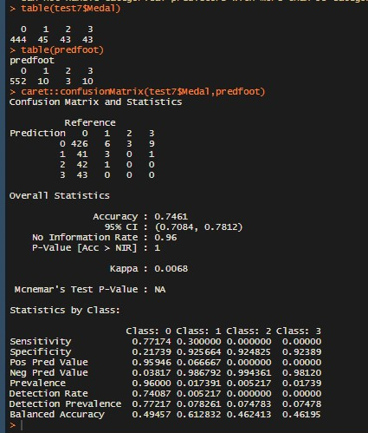

Figure 73: Results comparing test to predictions and confusion matrix for football

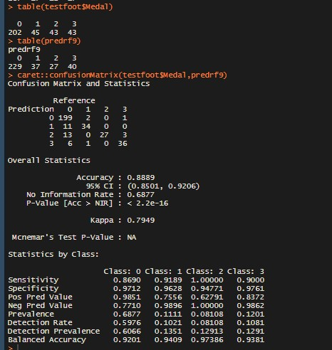

Figure 74: results and confusion matrix after selecting countries

WEIGHTLIFTING

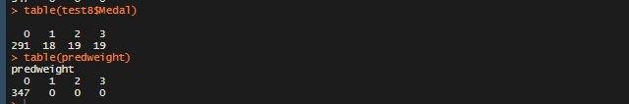

Figure 75: Comparing test with prediction before selecting countries

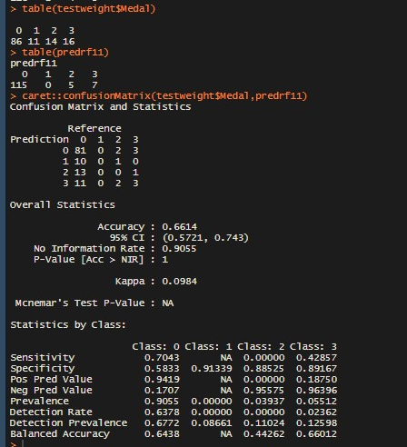

Figure 76: results and confusion matrix for weightlifting after selecting countries

## Appendix D: Monthly Journals

Reflective Journal

**Month: September**

September began and I had a rough idea of what I wanted my project idea to be. I wanted to predict the upcoming 2020 Tokyo Olympic Games. When I attended the first class of the Semester Eamon decided to stress everyone by basically saying if you don’t have an idea you’re screwed. As you can imagine nobody was looking forward to this year.

The tasks given were to make a video description of your project and the idea will be accepted based on the description given in the video. I uploaded my video and the idea got accepted a week later by my supervisor Ade who was assigned to me. The other task was to get the project proposal done but the due date for that got extended as there were many other assignments for us to complete and it was difficult to make time for the project proposal.

I had my first supervisor meeting on Wednesday week 5 and he told me to have some preparations done for the meeting such as showing him datasets I found that would help me and more detail on how I want the project to go. Ade told me to have find additional datasets to support my project for the next meeting which I am currently working on.

**Month: October**

In October the only tasks I had were to begin the proposal and upload and gather the additional requirements given by Ade. I have uploaded the proposal which still requires some changes. I am currently looking for additional datasets that will support my project. I decided to add some more complexity to my project by using GDP of a country to see how this would affect a countries performance in the games and that if every country theoretically had wealthy economies there would be no physical or athletic advantage between athletes from different countries. I am still developing on this idea and I will be adding to its complexity.

**Month November**

In November I began my literature review and finished my project plan. My literature review is still in the works. I also needed to begin my requirements specification which for which I have uploaded my first draft for it. I aim to complete before my midpoint presentation. I have been working on the coding aspect of my project, unfortunately due to a lot of other project due dates I have not been giving this part of my project enough time however I am working on it whenever I can and I aim to have a viable amount of code for my mid-point presentation to show my project. I am also looking for additional datasets for financial statistics on other countries so that I have a large amount of data to work with and show my skills when working with that size of data.

**Month December**

In December I spent most of my time getting ready for my midpoint presentation and I needed to add to my midpoint document. I received my date for my midpoint presentation which was on the 19th of December which made me relieved as it gave me more time to complete my prototype and it allowed me to spend time on getting more done with the document.

Once I was done with the document I started working on my prototype, I decided to make the prototype for the GUI first, I did this using HTML, CSS & Bootstrap. I spent a decent amount of time on making the GUI, once I was done, I started working on my code, unfortunately I wasn’t able to get much working on my code for my project. But it gave me an idea for where I can improve on during my free time after my exams. The day of the presentation came, and I did my presentation. I felt nervous about it, I didn’t think I did well at the time. The results for the presentation came out the next day and I got 63%! I guess I didn’t do bad. After the presentation i needed to upload an assignment which was due on the 21st, once I uploaded that I gave myself a few days off and then began to study for my exams which start on the 6th of January.

**Month January**

In January once I finished up with my exams, I enjoyed the time off I had. On the 28th I flew out to Pakistan to attend my sister’s wedding which was great I didn’t bring my laptop as I knew I wasn’t going to have time to work on it, also I worried if I did bring it, it might get lost or robbed. I will be back home on the 10th of February.

**Month: February**

I arrived back on the 10th very jetlagged at around 11pm. I was very tired, so I did not go to college the next day. While catching up with classmates on Wednesday I had learned that I missed out on a lot in class. The remainder of the month consisted of me trying to catch up with work and working on my Data Mining assignment & Advanced Business Data Analytics CA’s. I did not make much time for my project and did not have a meeting with my supervisor however I did email him and ask him for feedback on my presentation. He replied and told me my table of contents for the documentation was incorrect and I need to start working on a literature review.

**Month: April**

The covid-19 outbreak was receiving more attention and the first case had been reported it was an unsure time in college as we did not know what would happen. I still had assignments and CA’s to complete. Unfortunately, I did not make much progress on my project and I did not attend any supervisor meetings.

**Month: March**

It is apparent that the college would be shutdown sometime this month. I still focused on my assignments which were due. I also managed to write up a literature review for my project and I cleaned my dataset. I did not attend a supervisor meeting. Finished the assignments that were given as a replacement for the exams, it took up a lot of time and I was not sure if I would get my project done.

**Month: May**

I got a deferral for my Final year project and decided to take the month off from work as it had taken a huge toll on my mental health. I did have a meeting with my supervisor on the 10th of May.

**Month: June**

I started conducting analysis on my data, I first got my visualizations I then started working on trying to predict which country would win which event. I spent a lot of time on this as discussed with Ade I would use two machine learning algorithms for this task. I ended up using Random Forrest and Multinomial Logistic regression as they work with classification data. I was not aware that Ade had left the college and I found out that Frances was my supervisor.

**Month: July**

I was still working on seeing which country would win medals in the various sports, but I was not getting anywhere. I had concluded that you cannot use the data I have to predict these outcomes. I needed to move on and start my time series forecasting and statistical tests. I had a meeting with Frances, and she told me to change the aim of the project. Now I would be seeing if you can use an athlete’s attributes to predict the outcome of certain sports. I spent the weekend working on this and I got some positive results and I also finished with the time series and statistical test. I am currently working on the documentation and hope to have it finished by the 30th of this month leaving the weekend for my presentation recording.

**My Achievements**

**September:**

I was able to make my video description for my project and find datasets to for my project.

**October:**

I found a data set for my projects and began my proposal which will be changed throughout the course of the semester.

**November:**

I began my literature review, completed my project plan, began my requirements specification & I began coding for my project.

**December:**

I made my prototype for the GUI of my project which shows what I want the end application to look like. I received a 63% grade for my presentation.

**March:**

I written my literature review and cleaned my dataset.

**My Reflection**

**November**

I felt, it worked well to discuss my project with others in my class as they gave me a lot of advice on what to do. At times I was worried that I did not have enough for my project, so I asked my supervisor and he said it was all good.

However, I was not successful in completing my requirement specification which I did intend on doing however due to other module deadlines I had to take away time from my requirements specification.

**December**

The first semester was very over whelming, but I am glad to say I got through it all with onlyexams left.

**January**

I enjoyed my time-off, however I should have done some research for my project before flying to Pakistan.

**February**

Disappointed that I didn’t work on my project and didn’t attend any meetings. Will try to make a better effort next month.

**April**

Once again, a failed to make any progress on my project and did not attend any meetings.

**March**

Was a tough month and was glad I did some work on my project but worried that I will not finish the project.

**May**

After getting the deferral approved, I felt at ease need time off and come back more motivated.

**June**

I am glad I have gotten a decent amount of work done, I’ve learned a lot and I’ve implemented it.

**July**

I am pleased and happy with the work I have done on my project

**Intended Changes**

**November**

Next month, I focus more towards the coding aspect on my project and make sure that I have something running that will give people an idea of what I am pursuing with my project. I will also be finishing up on my requirements specification.

**December**

I believe learning python will be a big benefit to my project so I will be trying my best to make time for studying python and improving my skills in R.

I need to get my code working, get rid of errors and get some actual outputs.

**June**

I will not be needing to learn python as after researching I can complete this project in R.

**July**

Change the aim of the project. Now I would be seeing if you can use an athlete’s attributes to predict the outcome of certain sports.

**Supervisor Meetings**

**Date of Meeting: 16/09/2019**

***Items discussed:*** Project Idea, gather additional datasets.

**Action Items:** N/A

**Date of Meeting: 06/11/2019**

**Items discussed:** was advised to begin literature review and make a project plan. Also, to begin coding.

**Date of Meeting: 11/12/2019**

***Items Discussed:*** What to prepare for the Mid-Point presentation

**Date of Meeting: 10/05/2020**

***Items Discussed:*** what machine learning models to use, use tableau for visualizations.

**Date of Meeting: 17/07/2020**

***Items Discussed:*** what I had done so far and the results I gathered, and update on documentation.

**Date of Meeting: 21/07/2020**

***Items Discussed:*** change the approach of my aims and work on the other aims of my project